# UNIVERSITY OF PATRAS

**DEPARTMENT OF ELECTRICAL AND COMPUTER**

**ENGINEERING**

**DIVISION of electronics and computers (PC)**

**INTERACTIVE TECHNOLOGIES LABORATORY**



**Design and Development of a Location-Based Customer support application for Supermarkets**

**D I P L O M A T H E S I S**

## PANAGIOTIS ARVANITIS

**SUPERVISOR: NIKOLAOS AVOURIS**

**PATRAS –2024**

University of Patras, Department of Electrical and Computer Engineering.

Panagiotis Arvanitis

© 2024 – All rights reserved

The whole work is an original work, produced by Panagiotis Arvanitis, and does not violate the rights of third parties in any way. If the work contains material which has not been produced by him/her, this is clearly visible and is explicitly mentioned in the text of the work as a product of a third party, noting in a similarly clear way his/her identification data, while at the same time confirming that in case of using original graphics representations, images, graphs, etc., has obtained the unrestricted permission of the copyright holder for the inclusion and subsequent publication of this material.

# ABSTRACT

**Design and Development of a Location-Based Customer support application for Supermarkets**

|  |  |
| --- | --- |
| **STUDENT NAME, SURNAME:**  **ARVANITIS PANAGIOTIS** | **SUPERVISOR NAME, SURNAME:**  **AVOURIS NIKOLAOS** |

The subject of this thesis was the development and design of a location-based customer support application for supermarkets. The application aims to enhance customer experience by providing real-time assistance and personalized shopping recommendations. Customers can input their shopping list, and based on various factors such as weather, distance, means of transport, cost at each supermarket, and time of day, an AI model recommends the optimal supermarket for their shopping. The system integrates geolocation technologies to provide accurate guidance and suggestions, improving the overall shopping experience.

Key technologies used in the implementation include React and Bootstrap for the front end, offering a responsive and dynamic user interface. React's component-based architecture and Bootstrap's pre-designed components facilitate efficient UI development. Vite was used as the build tool for its fast development server and optimized build process. Node.js and Express power the backend, providing a robust and scalable server environment. Flask is employed alongside scikit-learn for the AI recommendation system, with the GradientBoostingRegressor algorithm implemented in Jupyter notebooks to handle the recommendation logic. Flask's lightweight framework and scikit-learn's extensive machine learning tools ensure efficient and effective AI model deployment.

Testing scenarios demonstrate the application's effectiveness in offering tailored shopping advice, leading to improved customer satisfaction and operational efficiency. A usability study evaluates the application's performance, providing insights into user interaction and potential areas for enhancement. The findings suggest that the application significantly enhances the customer support experience, making it a valuable tool for modern retail environments.

Keywords: Location-Based Services, Customer Support, Supermarket Application, Geolocation, AI Recommendations, React, Bootstrap, Vite, Node.js, Express, Flask, scikit-learn, GradientBoostingRegressor, Jupyter Notebook, User Experience, Retail Technology, Mobile Application Development.

# ΕΚΤΕΤΑΜΕΝΗ ΕΛΛΗΝΙΚΗ ΠΕΡΙΛΗΨΗ

**Μελέτη συστήματος ανίχνευσης τηλεφωνικής απάτης σε πραγματικό χρόνο με τεχνολογία μηχανικής μάθησης**

**ΟΝΟΜΑΤΕΠΩΝΥΜΟ ΦΟΙΤΗΤΗ: ΟΝΟΜΑΤΕΠΩΝΥΜΟ ΕΠΙΒΛΕΠΟΝΤΟΣ:**

**ΑΡΒΑΝΙΤΗΣ ΠΑΝΑΓΙΩΤΗΣ ΑΒΟΥΡΗΣ ΝΙΚΟΛΑΟΣ**

Αντικείμενο της παρούσας διπλωματικής εργασίας ήταν η ανάπτυξη και ο σχεδιασμός μιας εφαρμογής υποστήριξης πελατών με βάση την τοποθεσία για σούπερ μάρκετ. Η εφαρμογή στοχεύει στη βελτίωση της εμπειρίας των πελατών παρέχοντας βοήθεια σε πραγματικό χρόνο και εξατομικευμένες προτάσεις αγορών. Οι πελάτες μπορούν να εισάγουν τη λίστα με τα ψώνια τους και με βάση διάφορους παράγοντες, όπως ο καιρός, η απόσταση, το μέσο μεταφοράς, το κόστος σε κάθε σούπερ μάρκετ και η ώρα της ημέρας, ένα μοντέλο τεχνητής νοημοσύνης συνιστά το βέλτιστο σούπερ μάρκετ για τα ψώνια τους. Το σύστημα ενσωματώνει τεχνολογίες γεωεντοπισμού για να παρέχει ακριβή καθοδήγηση και προτάσεις, βελτιώνοντας τη συνολική εμπειρία αγορών.

Οι βασικές τεχνολογίες που χρησιμοποιήθηκαν στην υλοποίηση περιλαμβάνουν το React και το Bootstrap για το front end, προσφέροντας μια ευέλικτη και δυναμική διεπαφή χρήστη. Η αρχιτεκτονική του React που βασίζεται σε συστατικά και τα προσχεδιασμένα συστατικά του Bootstrap διευκολύνουν την αποτελεσματική ανάπτυξη του UI. Το Vite χρησιμοποιήθηκε ως εργαλείο κατασκευής για τον γρήγορο διακομιστή ανάπτυξης και τη βελτιστοποιημένη διαδικασία κατασκευής. Το Node.js και η Express τροφοδοτούν το backend, παρέχοντας ένα στιβαρό και κλιμακούμενο περιβάλλον διακομιστή. Το Flask χρησιμοποιείται παράλληλα με το scikit-learn για το σύστημα συστάσεων AI, με τον αλγόριθμο GradientBoostingRegressor να υλοποιείται σε Jupyter Notebook για να χειριστεί τη λογική των συστάσεων. Το ελαφρύ framework του Flask και τα εκτεταμένα εργαλεία μηχανικής μάθησης του scikit-learn εξασφαλίζουν την αποδοτική και αποτελεσματική ανάπτυξη μοντέλων AI.

Τα σενάρια δοκιμών καταδεικνύουν την αποτελεσματικότητα της εφαρμογής στην παροχή εξατομικευμένων συμβουλών αγορών, οδηγώντας σε βελτιωμένη ικανοποίηση των πελατών και λειτουργική αποτελεσματικότητα. Μια μελέτη ευχρηστίας αξιολογεί την απόδοση της εφαρμογής, παρέχοντας πληροφορίες σχετικά με την αλληλεπίδραση των χρηστών και τους πιθανούς τομείς για βελτίωση. Τα ευρήματα υποδηλώνουν ότι η εφαρμογή βελτιώνει σημαντικά την εμπειρία υποστήριξης πελατών, καθιστώντας την πολύτιμο εργαλείο για σύγχρονα περιβάλλοντα λιανικής πώλησης.

Λέξεις-κλειδιά: Υπηρεσίες βάσει τοποθεσίας, Υποστήριξη πελατών, Εφαρμογή σούπερ μάρκετ, Γεωεντοπισμός, Συστάσεις AI, React, Bootstrap, Vite, Node.js, Express, Flask, scikit-learn, GradientBoostingRegressor, Jupyter Notebook, Εμπειρία χρήστη, Τεχνολογία λιανικής, Ανάπτυξη εφαρμογών για κινητά.

# ACKNOWLEDGEMENTS

With the completion of this dissertation, I conclude my studies at the University of Patras. I would like to express my deepest gratitude to my supervisor, Mr. Nikolaos Avouris, for his invaluable support and guidance throughout this journey. His insights and expertise were crucial in navigating the challenges I encountered, and I am sincerely thankful for his continuous encouragement.

I would also like to extend my heartfelt thanks to my parents, girlfriend, and friends. Their unwavering support, belief in me, and constant presence by my side were instrumental in my success.

# Table Of Contents

UNIVERSITY OF PATRAS 1

PANAGIOTIS ARVANITIS 1

ABSTRACT 3

ΕΚΤΕΤΑΜΕΝΗ ΕΛΛΗΝΙΚΗ ΠΕΡΙΛΗΨΗ 4

ACKNOWLEDGEMENTS 5

Table Of Contents 6

Table Of Figures 9

1. Introduction 12

2. Analysis of the problem under research 13

2.1 Understanding the Problem Context 13

2.2 Real-Life Scenarios and Challenges 14

2.3 Technological and AI Integration 14

2.4 Enhancing User Decision-Making 15

2.5 Conclusion 15

3. Application Ecosystem 16

3.1. Frontend / Client Layer 16

React 16

Material-UI (MUI) 17

Leaflet 17

3.2 API Layer 17

Web Services API 17

3.3 Backend / Server Layer 18

Node.js 18

Express.js 18

3.4. AI / Recommendation Layer 18

Jupyter 18

scikit-learn 19

Flask 19

3.5 Database Management 19

PostgreSQL 19

pgAdmin 20

3.6 Administrative Layer 20

Netlify 20

GitHub 21

Render 21

3.7 Interactions 21

Frontend to Backend 21

Backend to Database 22

Backend to AI Layer 22

Deployment and Management 22

4. Recommendation Model 22

4.1 How GradientBoostingRegressor (GBR) Works 22

4.2 Comprehensive Explanation of GradientBoostingRegressor 22

4.3 Integration into the Application 23

4.4 Practical Application 24

4.5 History of GradientBoostingRegressor and Its Implementation 24

Assumptions and Considerations 25

General Gradient Boosting Regressor Algorithm 25

Algorithm 1: Gradient_Boost 26

Derivation of the Gradient Boosting Tree Regression Algorithm 27

Updating the Loss Function 28

Implementing the Algorithm with Decision Trees 28

5. Dataset Creation 29

5.1 Synthetic Data and Its Generation 29

What is AI powered synthetic data generation and how does it work? 30

Key Points about synthetic data: 30

Mostly.AI Platform 30

5.2 Foundational Dataset creation 30

Features 30

Methodology for the creation of the foundational dataset 31

5.3 Training/Testing Dataset Creation using Synthetic Data generators 41

Synthetic data generation 41

Mostly AI generation process 41

6. Database 43

6.1 Technologies used 43

PostgreSQL overview 43

pgAdmin overview 44

6.2 Database structure 44

Product 45

ProductSupermarket 45

Supermarket 45

Category 45

Cart and Cart_Products 45

User and User_Roles 46

WeatherCondition 46

MeansOfTransport 46

Heatmap 46

6.3 Queries for Data Retrieval and Analytics 46

Query examples 47

6.4 Collecting and importing large volumes of real world data 47

Gathering Data Using Web Scraping 48

Tools Used for Web Scraping 48

Data Engineering 49

7. Backend Architecture 50

7.1 Node.js Server 50

Structure: Routes, Controllers, and Middleware 51

Defining the API Endpoints 51

Authentication Routes and Controllers 51

User edit Routes and Controllers 52

Cart Management Routes and Controllers 53

Recommendation Routes and Controllers 54

Product and Category Management Routes and Controllers 60

7.2 Middleware in the Backend: JWT and its Implementation 61

JWT Overview 62

Structure of a JWT 62

Usage in Backend 63

Implementation of JWT in Backend 63

Other Middleware Implementations in the Project 65

Using Middleware in Routes 65

Summary of JWT Middleware Workflow 66

7.3 Python Server for Supermarket Recommendations: Gradient Boosting Regressor Model 66

Python Server Overview 66

Gradient Boosting Regressor (GBR) Model 67

Data Flow Between Node.js and the Python Server 67

Data Processing in Python 69

Model Prediction and Response 69

Core Components of the Python Server 70

Preprocessing Logic 70

Benefits of Using a Python Server with GBR 70

8. Frontend Design 71

Home Page 71

Subcategory Page 72

Product Listing Page 74

Cart 74

Checkout Page 75

Transportation Method Selection 76

Location Information 76

Cart Review 76

Recommendation Page 77

Sing Up/Sing In Page 78

Sign In Page 78

Sing Up Page 79

Account Page 80

Profile Information 80

Saved Carts Management 80

Help Chat Page 81

Key Features of the Help Page 82

9. Experimental Results 85

Fig 55: Testing Workflow 85

9.1 Model Performance on Familiar 'Vishing' Conversation 86

Fig 58: Vishing conversation with Unknown formatting 88

9.5 Response Time Performance Evaluation 91

9.6 Overall Results 91

10. Deductions, Limitations and Future Research 93

Bibliography 94

# Table Of Figures

Fig 1: Mobile Phone Phishing Attack ....................................................................................... 18

Fig 2: Spark Cluster Architecture [16] ...................................................................................... 23

Fig 3: Spark Main Components [17] ........................................................................................ 24

Fig 4: RDD lineage graph [13] .................................................................................................. 25

Fig 5: Spark SQL Interaction with Spark and RDDs [15] ........................................................... 25

Fig 6: Key Features of Spark’s Machine Learning package [18] .............................................. 26

Fig 7: Spark Machine Learning Pipeline Example [23] ............................................................. 28

Fig 8: Typical Streaming Process [24] ...................................................................................... 29

Fig 9: General Speech to Text Architecture [26] ..................................................................... 30

Fig 10: Speech to Text: Analog to Digital signal conversion .................................................... 31

Fig 11: The Transformer – Model Architecture [30]................................................................ 33

Fig 12: The Original Generative Pretrained Transformer Model [28] ..................................... 34

Fig 13: Dataset Creation Pipeline ............................................................................................ 36

Fig 14: Result of a normal (non-scam) conversation from Chat GPT API. ............................... 37 Fig 15: Result of a scam conversation from Chat GPT API. ..................................................... 37

Fig 16: Conversation Split to Support Better Training with the aim of supporting Real-Time

functionality. ........................................................................................................................... 38 Fig 17: Example of the above Dataset Preparation ................................................................. 38

Fig 18: Initial Preprocessing Pipeline ....................................................................................... 40

Fig 19: Word Tokenization Example [34]................................................................................. 41

Fig 20: Example of Stemming in the English language [38] ..................................................... 42

Fig 21: Indicative Data Post Initial Preprocessing .................................................................... 42

Fig 22: Example Output from the Initial Preprocessing Pipeline ............................................. 43

Fig 23: Preprocessing Pipeline for Model Training .................................................................. 43

Fig 24: Example of Data Post-Processing Through the Model Training Preprocessing Pipeline

................................................................................................................................................. 45

Fig 25: Example of Overfitting [53]. ......................................................................................... 49

Fig 26: Example of Early Stopping Point [50]........................................................................... 49

Fig 27: Diagram of K-fold cross-validation [54] ....................................................................... 51

Fig 28: Example of SVM hyperplane [60] ................................................................................ 55

Fig 29: Support Vectors [61] .................................................................................................... 55

Fig 30: A decision tree illustrating analysis of survival in Titanic Sinking [62] ......................... 56

Fig 31: Sequential Construction of Trees in Gradient Boosting [68] ....................................... 58

Fig 32: Depiction of the Structure of a Neural Network [69] .................................................. 59

Fig 33: Depiction of Neuron’s Output Calculation [70] ........................................................... 60

Fig 34: Simple Example of Neural network Structure ............................................................. 63

Fig 35: LSTM Cell Structure [78] .............................................................................................. 64

Fig 36: LSTM Neural Network Structure Example ................................................................... 65

Fig 37: Hyperparameter range of values for Logistic Regression ............................................ 67

Fig 38: Logistic Regression Training Results ............................................................................ 67

Fig 39: Hyperparameter range of values for Random Forest .................................................. 68 Fig 40: Random Forest Training Results .................................................................................. 68

Fig 41: Hyperparameter range of values for Support Vector Machines ................................. 68

Fig 42: Support Vector Machines Training Results .................................................................. 69

Fig 43: Hyperparameter Range of Values for Gradient Boosted Trees ................................... 69

Fig 44: Gradient Boosted Trees Training Results ..................................................................... 69

Fig 45: Optimal Hyperparameters as a result of the tuning process for the Neural Network 71

Fig 46: Neural Network Training Numerical Results ............................................................... 72

Fig 47: Hyperparameter Tuning Ranges for the LSTM Model Tuning ..................................... 73

Fig 48: Optimal Hyperparameters as a result of the tuning process for the LSTM Network .. 73

Fig 49: LSTM Network Training Results ................................................................................... 74

Fig 50: All Model Results ......................................................................................................... 75

Fig 51: Complete System Functionality Workflow .................................................................. 76

Fig 52: Stage One of the Complete System Workflow ............................................................ 76

Fig 53: Stage Two of the Complete System Workflow ............................................................ 77

Fig 54: Stage Three of the Complete System Workflow .......................................................... 78

Fig 55: Testing Workflow ......................................................................................................... 80

Fig 56: ‘Vishing' Conversation with Known Formatting .......................................................... 81

Fig 57: Model Results on Familiar ‘Vishing’ Conversation....................................................... 81

Fig 58: Vishing conversation with Unknown formatting ......................................................... 82

Fig 59: Model Results on Unknown ‘Vishing’ Conversation .................................................... 83

Fig 60: Normal conversation with Known Formatting. ........................................................... 84

Fig 61: Model Results on Familiar ‘normal’ Conversation ....................................................... 84

Fig 62: Normal conversation with Unknown Formatting. ....................................................... 85

Fig 63: Model Results on Unknown ‘normal’ Conversation .................................................... 85

# 1. Introduction

The motivation for this project stemmed from observing my parents' constant efforts to find the best deals on supermarket products through TV ads and flyers. Their dedication to saving money on groceries inspired me to think about how technology could simplify and enhance this process. With the rise of big tech platforms like Skroutz, which aggregate prices and deals from various online stores, I saw an opportunity to create a similar tool for supermarket shopping. My aim was to develop an application that harnesses the power of AI and machine learning to provide real-time, personalized recommendations on where to find the best deals, making it easier for families like mine to save both time and money.

Moreover, I was driven by a desire to merge the worlds of AI/ML and full-stack application development. This project represents a confluence of my interests in cutting-edge technology and practical, user-centric design. By incorporating AI algorithms, such as the GradientBoostingRegressor, and using tools like React, Bootstrap, Node.js, Express, Flask, and scikit-learn, I aimed to create a robust, scalable, and user-friendly application. The challenge was to build a system that not only performs complex data analysis and provides accurate recommendations but also delivers a seamless and engaging user experience. This endeavor allowed me to explore and integrate multiple technological domains, pushing the boundaries of what a supermarket shopping assistant could achieve.

Ultimately, the goal of this project is to develop an application that can be used by everyone, democratizing access to the best supermarket deals and enhancing the overall shopping experience. By leveraging location-based services and AI-driven recommendations, the app aims to provide users with real-time assistance and tailored shopping suggestions based on factors such as weather, distance, transportation means, and current supermarket prices. This application not only helps users save money but also promotes smarter and more efficient shopping habits. In doing so, it contributes to the broader objective of making everyday life easier and more cost-effective for people from all walks of life.

# 2. Analysis of the problem under research

## 2.1 Understanding the Problem Context

When creating a location-based customer support application for supermarket shopping, several critical factors must be considered. These factors influence the recommendation of the best supermarket for a user, based on real-time conditions and user-specific preferences. The primary objective is to aid users in making informed decisions that optimize for cost, convenience, and time efficiency.

## 2.2 Real-Life Scenarios and Challenges

Consider the scenario where a user has created their grocery list, but it is raining, and they are on foot. The app needs to determine whether it is more beneficial to visit a farther, cheaper supermarket or a closer, slightly more expensive one. Another scenario might involve the user shopping late in the day, with supermarkets closing soon. Here, the decision revolves around whether to risk going to a distant, cheaper supermarket or opting for a nearby one to ensure they make it in time. These examples highlight the practical dilemmas the app is designed to resolve by using AI-driven recommendations.

**User Stories:**

* **User Story 1:** As a pedestrian during rainy weather, I want the app to recommend whether I should go to a closer, slightly more expensive supermarket or a farther, cheaper one, so that I can make an informed decision without getting caught in the rain unnecessarily.
* **User Story 2:** As a shopper late in the day, I want the app to suggest whether I should risk going to a distant, cheaper supermarket or choose a nearby one to ensure I can shop before closing time, optimizing both cost and convenience.

## 2.3 Technological and AI Integration

To address these challenges, the application integrates advanced technologies such as geolocation services, AI models, PostgreSQL for database management, and pgAdmin for database administration. The AI component, leveraging machine learning algorithms like GradientBoostingRegressor from scikit-learn, processes various input factors to generate optimal shopping recommendations. This approach ensures that the recommendations are not just based on static data but adapt to real-time conditions and user-specific contexts, providing a personalized and efficient shopping experience.

**Technologies Used:**

* **Geolocation Services:** Utilized to pinpoint the user's location accurately and facilitate recommendations based on proximity to supermarkets.
* **AI and Machine Learning:** Employed GradientBoostingRegressor from scikit-learn to analyze dynamic factors such as weather conditions, time of day, and transportation means. This allows the app to generate tailored recommendations that optimize for cost, convenience, and real-time conditions.
* **Database Management:** PostgreSQL used to store and manage application data efficiently, ensuring robust data handling and retrieval capabilities.
* **Database Administration:** pgAdmin employed for database administration tasks such as monitoring, querying, and managing PostgreSQL databases, providing a user-friendly interface for database management.
* **Frontend Technologies:** Developed using React.js and Bootstrap for a responsive and user-friendly interface, ensuring seamless interaction and intuitive navigation.
* **Backend Technologies:** Implemented with Node.js and Express.js to handle server-side operations, manage data, and integrate with external APIs for real-time updates.
* **Data Science Tools:** Leveraged Flask in conjunction with scikit-learn for backend AI model deployment and Flask-RESTful for creating APIs that interact with the AI models.

**User Stories:**

* **User Story 3:** As a user of the app, I expect it to utilize AI-driven algorithms to consider factors like weather conditions, time of day, and transport means when recommending supermarkets, ensuring the suggestions are tailored to my current situation.

## 2.4 Enhancing User Decision-Making

The primary goal is to shift user decision-making from intuition-based choices to data-driven recommendations. By considering a comprehensive set of factors including weather, distance, transportation means, and store operation hours, the app aims to provide users with the most convenient and cost-effective shopping options. This shift not only enhances the shopping experience but also contributes to significant savings in time and money for the users.

**User Stories:**

* **User Story 4:** As a shopper, I want the app to help me make data-driven decisions by providing recommendations based on factors like cost, distance, and real-time conditions, ensuring I can optimize my grocery shopping experience.

## 2.5 Conclusion

The application addresses a common problem faced by many shoppers by integrating AI and full-stack development to provide practical solutions. By making use of real-time data and personalized recommendations, it effectively enhances user decision-making, ensuring an improved overall shopping experience. This innovation represents a significant advancement in retail technology, offering tangible benefits to consumers.

**User Stories:**

* **User Story 5:** As a frequent shopper using the app, I want to save and access my grocery lists for different days, and receive recommendations based on these lists in advance, enabling me to plan my shopping trips efficiently and effectively.

# 3. Application Ecosystem

Achieving our goals of creating a well-structured full stack web application while also seamlessly merging Machine learning and AI recommendations requires a complex and well-integrated technology ecosystem. This involves leveraging various technologies and frameworks at different layers to ensure scalability, efficiency, and maintainability. Below is a detailed overview of the technologies used across different layers of our web application architecture:

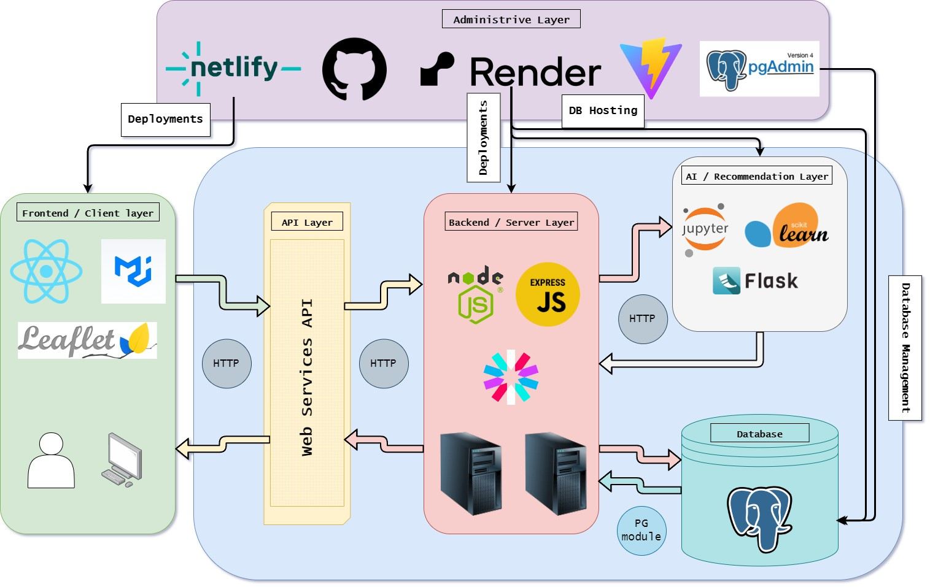

Figure 1: Applications Ecosystem

## 3.1. Frontend / Client Layer

### React

* **Description**: React [16] is a free and open-source JavaScript library used for developing user interfaces. It is widely recognized as the most popular solution for the rapid and efficient creation of complex user interfaces, and it is employed in the development of both web and mobile applications. Applications developed with React are divided into smaller parts called components, each with specific functionality. For example, a navigation bar at the top of a webpage could be a separate component. This modular approach results in a large and complex component, a webpage, that is composed of many smaller components [16]. One of the main advantages of using React is the ease it offers in application development. React achieves this speed through a Virtual DOM (Document Object Model). The Virtual DOM tracks the application's data, comparing previous states and updating only the elements in the actual DOM where a change is detected, instead of fully refreshing the page as in conventional web applications. React.js also benefits from a large and active community, providing a wealth of resources, libraries, and add-ons that can be easily integrated into applications. Overall, React.js is a suitable choice for creating dynamic and responsive user interfaces due to its component-based architecture, Virtual DOM, and efficient rendering.
* **Advantages**: Component-based architecture, fast rendering with Virtual DOM, and a strong ecosystem of libraries.
* **Used for**: Front end development

### ****Material-UI (MUI)****

* **Description**: A popular React UI framework that implements Google's Material Design.
* **Advantages**: Provides a comprehensive set of components, consistent design, and easy customization.
* **Used for**: Design purposes

### ****Leaflet****

* **Description**: An open-source JavaScript library for interactive maps.
* **Advantages**: Lightweight, easy to use, and highly customizable with a variety of plugins.
* **Used for**: Geolocation map rendering

## 3.2 API Layer

### **Web Services API**

* **Description**: This layer serves as the interface between the frontend and backend, handling HTTP requests and responses.
* **Advantages**: Decouples the frontend from the backend, facilitating independent development and scalability.
* **Used for**: Exchanging information between client and sever

## 3.3 Backend / Server Layer

### ****Node.js****

* **Description**: Node.js [15] is a free and open-source JavaScript runtime environment that has become one of the most popular choices for developers in web application development. Over the years, various programming languages have been used to process requests from web browsers on a server, such as PHP, Ruby, Python, ASP, and Java. In contrast, JavaScript was primarily used in browsers to provide interactivity on websites, such as dropdown menus [15]. In 2009, Ryan Dahl created Node.js, which is built on the V8 engine of the Google Chrome browser, enabling the execution of server-side JavaScript code. This allowed JavaScript to be used for developing applications on both the server side and the client side. Node.js implements an asynchronous, non-blocking input/output model through the use of events, using a single execution thread. Thus, when performing an input/output operation, such as reading data from a database, Node.js continues executing until the data is available instead of blocking the execution thread. Applications developed in Node.js are characterized by high speed and efficiency, making Node.js a suitable choice for applications that require high interactivity and real-time data updates. Another advantage of using Node.js is the ability to use a common language for developing both frontend and backend
* **Advantages**: Non-blocking, event-driven architecture, which allows handling multiple connections concurrently.
* **Used for**: Web server development

### ****Express.js****

* **Description**: Express.js [10] is a free and open-source library/framework for Node.js, used for the rapid and easier development of web servers that process requests from browsers. Express.js provides a higher level of abstraction compared to Node, making it easier for developers to utilize its functionality and additional capabilities [10]. One of the significant advantages of using Express.js is the use of JavaScript for both frontend and backend development in a web application. Therefore, developers do not need to learn or use any other language. Additionally, since it is based on the V8 engine of the Google Chrome browser, Express.js is an ideal choice for applications requiring fast response times and request processing, as well as for real-time applications.
* **Advantages**: Minimal and flexible, with a rich set of HTTP utility methods and middleware.
* **Used for**: Web server development

## 3.4. AI / Recommendation Layer

### Jupyter

* **Description**: Jupyter [23] is an open-source platform that provides interactive notebooks for data analysis, visualization, and machine learning. It supports various programming languages, including Python, R, and Julia, making it a versatile tool for data scientists and researchers. One of the significant advantages of using Jupyter is its ability to combine code, text, and visualizations in a single document, facilitating exploratory data analysis and collaboration. Jupyter notebooks enable users to document their analysis process, share insights, and reproduce results easily. Additionally, Jupyter's integration with various data science libraries and tools enhances its functionality, making it a powerful platform for data-driven projects.
* **Advantages**: Interactive data analysis and visualization, widely used in the data science community.
* **Used for**: Recommendation AI model development

### **scikit**-learn****

* **Description**: Scikit-learn [24] is a free and open-source machine learning library for Python. It provides simple and efficient tools for data mining and data analysis, built on top of NumPy, SciPy, and matplotlib. One of the main advantages of using Scikit-learn is its ease of use and consistency, offering a wide range of algorithms for classification, regression, clustering, and dimensionality reduction. Scikit-learn's comprehensive documentation and examples make it accessible for both beginners and experienced practitioners. The library's efficient implementation of machine learning algorithms ensures high performance and scalability, making it suitable for various data science and machine learning tasks.
* **Advantages**: Easy to use, well-documented, and integrates well with other scientific libraries like NumPy and SciPy.
* **Used for**: Recommendation AI model creation

### Flask

* **Description**: Flask [25] is a lightweight and flexible web framework for Python, designed for building web applications and services. It provides the essential components needed for web development, such as routing, templates, and request handling, while allowing developers to choose additional tools and libraries as needed. One of the primary advantages of using Flask is its simplicity and minimalism, enabling developers to quickly set up and build applications without unnecessary complexity. Flask's modular design allows for easy integration with other tools and extensions, making it adaptable to various project requirements. Additionally, Flask's active community provides extensive documentation, tutorials, and support, making it a popular choice for Python web development.
* **Advantages**: Lightweight, easy to set up, and suitable for building small to medium-sized web applications.
* **Used for**: Recommendation AI model server creation

## 3.5 Database Management

### **PostgreSQL**

* **Description**: PostgreSQL is a free and open-source object-relational database management system (ORDBMS) known for its robustness, scalability, and compliance with SQL standards. Originating from the POSTGRES project at the University of California, Berkeley, PostgreSQL has grown to become one of the most reliable and feature-rich database systems available today. It supports a wide range of data types and offers advanced features such as indexing, transaction management, and extensibility.
* **Advantages**: Robust features, support for advanced data types, and strong performance for complex queries.
* **Used for**: Database creation

### **pgAdmin**

* **Description**: pgAdmin [21] is a popular open-source administration and development platform for PostgreSQL databases. It provides a graphical interface for managing PostgreSQL databases, offering features like query execution, database design, and performance monitoring. One of the main advantages of using pgAdmin is its user-friendly interface, which simplifies database management tasks for both beginners and experienced users. pgAdmin supports advanced features like SQL editing, debugging, and database maintenance, making it a powerful tool for database administrators and developers. Additionally, pgAdmin's active community provides extensive documentation and support, ensuring that users can effectively manage their PostgreSQL databases.
* **Advantages**: User-friendly, comprehensive administrative tools, and supports multiple PostgreSQL versions.
* **Used for**: Database management.

## 3.6 Administrative Layer

### ****Netlify****

* **Description**: Netlify [18] is a modern platform for deploying and managing web projects. It offers a seamless and straightforward process for developers to deploy static websites and web applications. Netlify automates the entire deployment pipeline, from code changes to live updates on the web, providing continuous deployment from Git repositories. One of the major advantages of using Netlify is its ability to handle complex build processes and optimizations, allowing developers to focus on writing code without worrying about deployment complexities. Netlify also provides features like form handling, serverless functions, and split testing, which enhance the development and deployment process. The platform ensures high performance and security, making it an excellent choice for developers looking to streamline their deployment workflows.
* **Advantages**: Simplified deployment process, built-in CI/CD, and powerful build settings.
* **Used for**: Frontend deployments, Site hosting

### ****GitHub****

* **Description**: GitHub [19] is a web-based platform that uses Git for version control, making it easy for developers to collaborate on projects. GitHub hosts repositories in the cloud, providing tools for version control, issue tracking, project management, and collaboration. One of the primary advantages of using GitHub is its ability to facilitate collaboration among developers, enabling them to work on the same project simultaneously and merge their changes seamlessly. GitHub also offers features like pull requests, code reviews, and integrated continuous integration/continuous deployment (CI/CD) pipelines, which improve the development workflow. Additionally, GitHub's large and active community provides a wealth of resources, including open-source projects, libraries, and tutorials, making it a valuable platform for developers.
* **Advantages**: Facilitates collaboration, integrates with various development tools, and provides robust version control.
* **Used for**: Versioning

### ****Render****

* **Description**: Render [20] is a cloud platform that simplifies the process of deploying web applications and services. It provides a unified interface for deploying static sites, web services, and databases, automating the deployment process and managing infrastructure. Render supports various programming languages and frameworks, offering a flexible and developer-friendly environment. One of the significant advantages of using Render is its ability to handle scaling and load balancing automatically, ensuring that applications run smoothly even under high traffic conditions. Render also provides features like automated SSL certificates, private networking, and custom domains, enhancing the deployment and management process. The platform's simplicity and efficiency make it an excellent choice for developers looking to deploy and manage their applications in the cloud.
* **Advantages**: Simplifies infrastructure management, automatic scaling, and easy deployment of applications.
* **Used for**: Backend server hosting, Python server hosting, Database hosting, backend deployments

## 3.7 Interactions

### Frontend to Backend

The frontend sends HTTP requests to the backend via the Web Services API for data and functionality.

### Backend to Database

The backend communicates with the PostgreSQL database to perform CRUD (Create, Read, Update, Delete) operations using the PG module.

### Backend to AI Layer

The backend interacts with the AI layer to obtain recommendations and predictions, which it then forwards to the frontend via the API layer.

### Deployment and Management

Code is deployed to the web using Netlify and Render, with version control handled by GitHub. The database is hosted and managed using Render and pgAdmin.

# 4. Recommendation Model

The recommendation engine in this application leverages the GradientBoostingRegressor (GBR) algorithm to provide personalized suggestions on the best supermarket for users based on real-time conditions and user-specific preferences. This section outlines how GBR works within the context of the application, emphasizing its role in optimizing supermarket recommendations.

## 4.1 How GradientBoostingRegressor (GBR) Works

GradientBoostingRegressor (GBR) is a sophisticated machine learning algorithm that excels in regression tasks by sequentially building an ensemble of decision trees to improve prediction accuracy. Below is a comprehensive explanation of its operation:

## 4.2 Comprehensive Explanation of GradientBoostingRegressor

GradientBoostingRegressor is part of the boosting family of algorithms, which iteratively enhances the predictive ability of an ensemble of models, often referred to as weak learners. Here’s an in-depth look at its components and workings:

1. **Introduction to Boosting:** Boosting is an ensemble learning technique where models are built sequentially to correct the errors of the previous models. Unlike bagging methods, such as Random Forest, where models are trained independently, boosting methods focus on improving predictions by emphasizing instances where previous models have performed poorly.
2. **Gradient Boosting Framework:** GradientBoostingRegressor optimizes a differentiable loss function, typically the mean squared error (MSE) for regression tasks. Here’s the step-by-step process:
   * **Initialization:** GBR starts with an initial prediction, often the mean of the target values.
   * **Gradient Calculation:** It computes the negative gradient of the loss function with respect to the current model's prediction. This gradient points towards the direction of steepest descent, aiming to minimize the loss.
   * **Model Fitting:** A new decision tree model (weak learner) is trained to predict the negative gradient. This tree is fitted to the residuals (the difference between actual and predicted values) of the previous model.
   * **Gradient Descent Update:** The predictions from the new tree are added to the current model's predictions, updating them in the direction that minimizes the loss function.
3. **Sequential Learning and Adaptation:**
   * **Iterative Improvement:** Each subsequent model (tree) in the ensemble focuses on reducing the errors made by the previous ensemble of trees.
   * **Adaptive Learning Rate:** GBR employs a shrinkage parameter (learning rate) to scale the contribution of each tree. Lower learning rates typically lead to more robust models by reducing overfitting risks and improving generalization.
4. **Key Parameters and Tuning:** GBR offers several parameters to optimize its performance:
   * **Number of Trees (n_estimators):** Determines the number of boosting stages (trees) to be built.
   * **Tree Depth (max_depth):** Controls the maximum depth of each decision tree. Deeper trees can model more complex relationships but may lead to overfitting.
   * **Learning Rate (learning_rate):** Scales the contribution of each tree. Lower values require more trees for convergence but often yield better performance.
   * **Loss Function (loss):** Specifies the loss function to be optimized (e.g., 'ls' for least squares regression).
5. **Benefits of GradientBoostingRegressor:**
   * **High Predictive Accuracy:** GBR consistently improves prediction accuracy by iteratively refining predictions based on previous errors.
   * **Handling Non-linear Relationships:** Its ensemble nature allows it to capture complex relationships between input features and target variables effectively.
   * **Robust to Overfitting:** Techniques like shrinkage (learning rate) and tree pruning (max_depth) mitigate overfitting risks, ensuring better generalization to unseen data.
6. **Practical Applications:**
   * **Financial Forecasting:** Predicting stock prices or market trends based on historical data.
   * **Healthcare Analytics:** Predicting patient outcomes or disease progression using medical data.
   * **Retail and Marketing:** Predicting customer behavior or sales forecasts based on demographic and transactional data.

## 4.3 Integration into the Application

In this application:

* **Data Input:** The application receives data about supermarkets, including distances from the user, costs of the grocery lists,the means of transport of the user,the current weather conditions, and the time of day.
* **Data Processing:** Upon receiving user data, the application constructs a DataFrame and preprocesses it to align with the format required by the GBR model.
* **Model Prediction:** Using the trained GBR model (model.pkl), the application predicts a score for each supermarket based on the input features. These scores reflect the suitability of each supermarket given the user’s current context.
* **Recommendation Generation:** Post prediction, the application generates recommendations by sorting supermarkets based on their scores in descending order. It then provides users with the top recommendations, ensuring they receive personalized suggestions that consider factors such as distance, cost, weather conditions, means of transport, and the time of day.

## 4.4 Practical Application

The integration of GBR ensures that the application provides real-time, data-driven recommendations that enhance user decision-making in supermarket shopping. By dynamically adjusting to changing conditions and user preferences, the application not only simplifies the shopping experience but also optimizes for cost-effectiveness and convenience.

By using the workings of GBR and its application in this context, users can confidently rely on the application to navigate supermarket choices effectively, ultimately saving time and money.

This seamless integration of advanced machine learning techniques like GBR underscores the application’s commitment to providing value through technology, empowering users to make informed decisions in their daily lives.

## 4.5 History of GradientBoostingRegressor and Its Implementation

Gradient Boosting Regressor is a sophisticated form of the boosting ensemble method, which was initially discussed in a previous article. The development of gradient boosting builds upon the concepts introduced with Adaboost. It was noted that boosting can be framed as an optimization problem over a loss function (refer to Breiman 1997). This realization inspired the creation of gradient boosting—a general algorithm capable of handling various loss functions and model types (often referred to as "Weak Learners"). Typically, in practice, the weak learner used is a Decision Tree.

Since their inception in the late 1990s, gradient boosting algorithms have become highly favored for both online competitions and commercial machine learning applications, thanks to their versatility and superior predictive accuracy. For instance, the Extreme Gradient Boosting (XGBoost) package is widely used in industry and frequently excels in Kaggle competitions. Newer packages like LightGBM are also gaining traction across a range of practical problems.

For the project’s implementation, the focus will be on the Gradient Boosting Regressor using Decision Trees, as described in Algorithm 3 of Friedman (2001).

### Assumptions and Considerations

When developing a Gradient Boosting Regressor, consider the following key points:

1. The model is designed to address regression problems involving continuous variables.
2. The selected loss function must be differentiable.
3. The assumptions underlying the weak learner models used to build the ensemble must be considered. For this discussion, we will consider the assumptions behind Decision Tree Regressors.
4. There must be a feasible solution for the chosen fitting procedure and weak learner model (see Algorithm 1, Step 4, in the following section).

### General Gradient Boosting Regressor Algorithm

The general gradient boosting algorithm, as outlined in Algorithm 1 of Friedman (2001), is designed to handle any loss function ℓ and weak learner $f$, provided they adhere to the aforementioned assumptions.

We begin with some basic definitions. Our data consists of predictors X and targets y. We will index each unique sample in the data with $n = 1 …N$. Similarly, we will index each weak learner model in our ensemble with $m = 1 …M$.

$$X=\left[x_{1 } x_{2}… x_{n}…{ x}_{N}\right], y=\left[y_{1} y_{2 }…{ y}_{n}…{ y}_{N}\right]$$

where $x_{n}∈R^{d}$ and $y_{n}∈R$.

$$f_{m}\left(x_{n}\right)∈R, l\left(y_{n},f_{m}\left(x_{n}\right)\right)∈R$$

Here, equations (1), (2), and (3) describe the data, weak learner model, and loss function, respectively. Note that **xn​** are the rows of the matrix ***X***, containing d features, and **yn**​ are the scalar values of the column vector **y**.

Similar to other boosting algorithms, Gradient Boosting operates sequentially. Each subsequent weak learner aims to correct the errors of the previous models. This is achieved through steepest descent. Specifically, the gradients of the loss function are computed and used as labels for $f_{m}$ ​. The output from $f_{m}$ ​ is then adjusted proportionally to each step in the boosting process, gradually approaching a minimum in the loss function space. The concept is illustrated below:

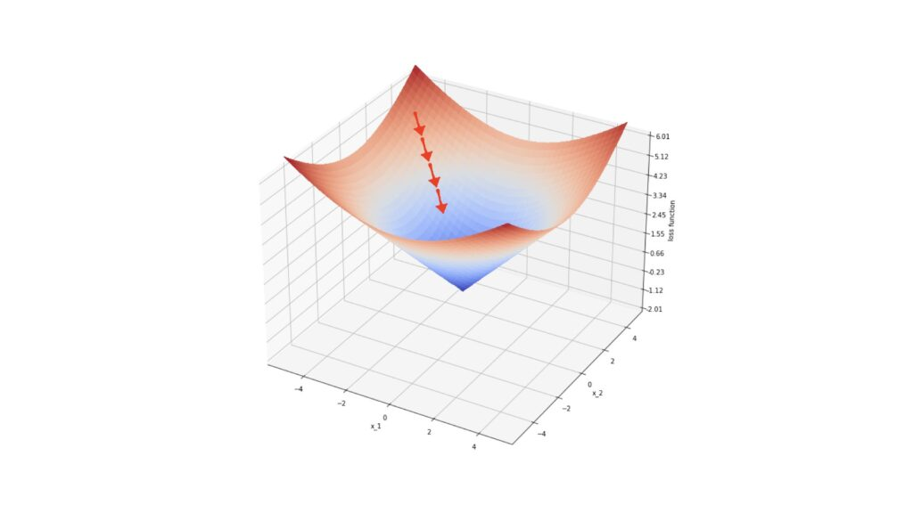

In the illustration, the red arrows represent gradients at specific points on the surface defined by ℓ. Each step in steepest descent moves our loss value closer to the local minimum.

With this understanding, let's outline the general gradient boosting regressor algorithm:

### Algorithm 1: Gradient_Boost

1. Initialize the ensemble:
$$E_{0}\left(x\right)=\arg{\min_{ρ}{\sum_{n=1}^{N}{l\left(y_{n},ρ\right)}}}=\text{median}\left(y\right)$$

2. For **m**=1 to **M**:
   1. Compute the negative gradients of the loss function with respect to the ensemble output at each data point **xn**​:
   2. Identify the weak learner $f$ that closely matches the gradients **gn**​, computed previously. This step generalizes the procedure to points **x** not included in the training data. Although various fitting procedures can be used, Friedman (2001) preferred least squares due to its computational properties.
   3. Determine the steepest descent multiplier $ρ_{m}$ ​, using the weak learner $f\left(x;θ_{m}\right)$ found in the previous step:
 $$ρ_{m} = arg⁡\min_{ρ}\sum_{n=1}^{N}{l\left(y_{n},E_{m-1}\left(x_{n}\right)+ρf\left(x_{n};θ_{m}\right)\right)}$$

  4. Update the ensemble:

$$E_{m}\left(x\right)=E_{m-1}\left(x\right)+ρ_{m}f\left(x;θ_{m}\right)$$

Each step in this algorithm can be explained in detail:

1. Initialize the ensemble to $E_{0}$
2. Compute the negative gradients of the loss function ℓ concerning the ensemble output at each data point **x­n**​. These gradients point towards the local minimum in the space defined by ℓ.
3. Identify the weak learner $f$ that correlates most closely with the gradients **gn** ​. Since the gradients are defined only at the points **x­n** ​, this step generalizes the procedure to other points. In Friedman (2001), least squares were used due to their computational advantages.
4. Determine the multiplier $ρ_{m}$ for steepest descent, using the weak learner $f\left(x;θ_{m}\right)$ identified in the previous step.
5. Increment the ensemble $E_{m}$ ​ using steepest descent.

### Derivation of the Gradient Boosting Tree Regression Algorithm

We can make Algorithm 1 more specific by defining the type of weak learner $f$ and loss function ℓ. Let's choose:

$$f\left(x;θ\right)=\sum_{j=1}^{J}{b_{j}I\left(x∈R_{j}\right)}, l\left(y,ρ\right)=\left|y-ρ\right|$$

Equation (4) describes a decision tree with $j = 1 …J$ terminal regions defined by $R_{j}$ ​ and $b_{j}$ ​ terminal values. Here, $I$ is the indicator function, and $θ=\{b_{j},R_{j}\}_{1…J}$. Equation (5) represents the absolute difference loss function.

Introducing equation (4) into Algorithm 1, Step 4 involves fitting the decision tree to the negative gradients ***g*** of the loss function using least squares. Step 5 is updated as follows:

$$ρ_{m}=arg{\min_{ρ}\sum_{n=1}^{N}{l\left(y_{n},E_{m-1}\left(x_{n}\right)\right)}}+ρ\sum_{j=1}^{J}{b_{j}I{(x}_{n}∈R_{jm})}$$

$$\{γ_{jm}\}_{1…J}=\arg{\min_{\{γ_{j}\}_{1…J}}{\sum_{n=1}^{N}{l\left(y_{n},E_{m-1}\left(x_{n}\right)+\sum_{j=1}^{J}{γ_{j}I\left(x_{n}∈R_{jm}\right)}\right)}}}$$

Here, $γ_{jm}$ ​ is a new optimum scaling factor over the possible $γ_{j}=ρb_{j}$ ​ values for region ***j*** at the ***m*** boosting step. Since the terminal regions produced by decision trees are disjoint, this expression can be simplified for a single value of j:

$$γ_{jm} = arg⁡\min_{γ}\sum_{x_{n}∈R_{jm}}{l\left(y_{n},E_{m-1}\left(x_{n}\right)+γ\right)})$$

Step 6 of Algorithm 1 is updated to:

$$E_{m}\left(x\right)=E_{m-1}\left(x\right)+ρ_{m}\sum_{j=1}^{J}{b_{jm}I\left(x∈R_{jm}\right)}$$

$$E_{m}\left(x\right)=E_{m-1}\left(x\right)+\sum_{j=1}^{J}{γ_{jm}I\left(x∈R_{jm}\right)}$$

### Updating the Loss Function

Introducing equation (5) into Algorithm 1, starting with Step 1, the argument minimum of $ρ$ is computed by taking the derivative and setting it to zero:

$$\frac{∂E_{0}\left(x\right)}{∂ρ}=\sum_{n=1}^{N}{\text{sign}\left(y_{n}-ρ\right)}=0 ⇒ E_{0}\left(x\right)=\text{median}\left(y\right)$$

Thus, our choice of loss function leads us to initialize the ensemble with the median of the training labels.

$$g_{n}=-\frac{∂\left|y_{n}-E\left(x_{n}\right)\right|}{∂E\left(x_{n}\right)}=\text{sign}\left(y_{n}-E\left(x_{n}\right)\right)$$

### Implementing the Algorithm with Decision Trees

To make the algorithm concrete, let’s specify decision trees as the weak learners $f$ and consider the absolute difference loss function $l\left(y,ρ\right)=\left|y-ρ\right|$

1. **Weak Learner**:

$$f\left(x;θ\right)=\sum_{j=1}^{J}{b_{j}I\left(x∈R_{j}\right)}$$

where 𝜃={𝑏j,𝑅j}​ are the terminal values and regions of the decision tree.

1. **Loss Function**:

$$l\left(y,ρ\right)=\left|y-ρ\right|$$

Using these specifications, we update the algorithm:

1. **Initialization**:
$$E_{0}=\text{median}\left(y\right)$$

2. **Negative Gradient**:
$$g_{n}=\text{sign}\left(y_{n}-E\left(x_{n}\right)\right)$$

3. **Fitting the Decision Tree** to the negative gradients:
$$θ_{m}=\arg{\min_{θ}{\sum_{n=1}^{N}{{\left[g_{n}-f\left(x_{n};θ\right)\right]}^{2}}}}$$

4. **Optimal Step Size**:
$$ρ_{m} = arg⁡\min_{ρ}\sum_{n=1}^{N}{l\left(y_{n},E_{m-1}\left(x_{n}\right)+ρf\left(x_{n};θ_{m}\right)\right)}$$

5. **Model Update**:

$$E_{m}\left(x\right)=E_{m-1}\left(x\right)+ρ_{m}f\left(x;θ_{m}\right)$$

In this detailed approach, each step incrementally improves the model by fitting a new decision tree to the current residuals (negative gradients) and updating the model in the direction that reduces the loss function, ultimately converging to a robust predictive model.

# 5. Dataset Creation

In this section, we delve into the methodology used to create the dataset for our research. Due to the sensitivity and constraints associated with acquiring real-world data, I opted to leverage the capabilities of the Mostly.AI platform to generate a comprehensive dataset.

## 5.1 Synthetic Data and Its Generation

Synthetic data refers to artificially created data rather than data collected from real-world sources. It is generated using algorithms or models to mimic the characteristics and distribution of real data. The process typically involves the following steps:

1. **Model Selection**: Choose an appropriate model or tool that can generate data similar to your real-world scenario.
2. **Parameterization**: Define the parameters and characteristics of the data you want to generate, such as distributions, correlations, and data types.
3. **Generation**: Utilize the selected model or tool to generate synthetic data based on the specified parameters.

### ****What is AI powered synthetic data generation and how does it work?****

Synthetic data generation is powered by deep generative algorithms. These algorithms use data samples as training data to learn the correlations, statistical properties, and data structures. Once trained, the algorithms can generate data that is statistically and structurally identical to the original training data, while ensuring all data points are synthetic.

### Key Points about synthetic data:

* **Synthetic data for AI and machine learning is more flexible than real data.** It accelerates analytics development cycles, reduces regulatory concerns, and lowers data acquisition costs by providing tailored datasets for specific applications.
* **An initial dataset is required.** An initial dataset needs to be constructed and fed to the synthetic data generation model in order to increase it’s volume in order to be substantial for the recommendation model

### Εικόνα που περιέχει κείμενο, στιγμιότυπο οθόνης, γραμματοσειρά, διάγραμμαMostly.AI Platform

Figure 2: Mostly AI convertion flow

The Mostly.AI platform provides robust capabilities for generating synthetic data. It employs advanced algorithms that mimic real data patterns while ensuring privacy and security. This platform was instrumental in creating our dataset, offering customizable options to tailor the data generation process to our specific research needs.

## 5.2 Foundational Dataset creation

### Features

The dataset used to train the model contains the following columns:

1. **ID**: A unique identifier for each record.
2. **TimeOfDay**: Indicates the time of day when the recommendation was generated (e.g., morning, afternoon, evening).
3. **Distance**: Distance from the user's location to the supermarket (in meters).
4. **WeatherCondition**: Describes the weather conditions at the time of recommendation (e.g., sunny, rainy, snowy).
5. **MeansOfTransport**: Specifies the mode of transportation considered for the recommendation (e.g., car, bike, walking).
6. **Cost**: Estimated cost of shopping at the supermarket based on a typical grocery list.
7. **Supermarket Rating**: The rating of the supermarket based on online reviews (scale 0 to 5)
8. **Score**: Numerical score indicating the suitability of the supermarket based on the above factors.

These features collectively enable the dataset to provide informed recommendations for grocery shopping based on user preferences and real-time environmental factors.

### Methodology for the creation of the foundational dataset

The foundational dataset creation process involved a structured methodology where raters sequentially evaluated each supermarket recommendation, with the ability to adjust ratings based on previous evaluations. Five groups of three raters where created with each group rating the suitability for recommendation of 100 supermarkets and conditions ranked on a scale from 0 to 100. Each group where given 100 different supermarkets from each other. The rating process is documented below.

1. **Sequential Rating Process**:
   * Raters for each group evaluated each supermarket recommendation one by one, starting from the first supermarket and moving sequentially through to the 100th supermarket.
   * For each supermarket, raters assessed its suitability for recommendation based on factors like TimeOfDay, Distance, WeatherCondition, MeansOfTransport, Cost, Supermarket Rating.
   * After rating a supermarket, raters recorded their numerical evaluation on a scale from 0 to 100.
2. **Dynamic Rating Adjustment**:
   * Crucially, raters had the flexibility to revisit and adjust their ratings for previously evaluated supermarkets based on subsequent evaluations.
   * 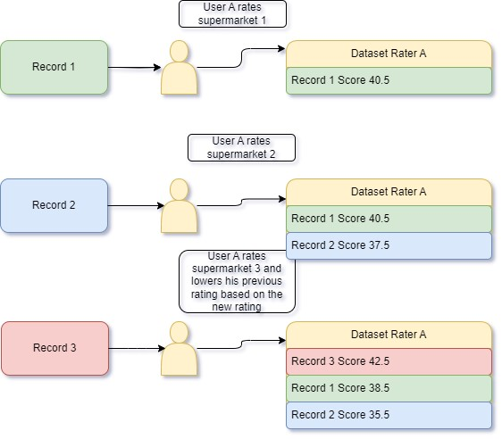This dynamic adjustment allowed raters to refine their assessments as they progressed through the dataset, potentially modifying earlier ratings in light of new insights or patterns observed in later evaluations.

Figure 3: Personal Dataset Creation process

1. **Mean Calculation**:
   * Once all 100 supermarkets were rated by the three raters, the mean (average) rating for each supermarket recommendation was calculated.
   * 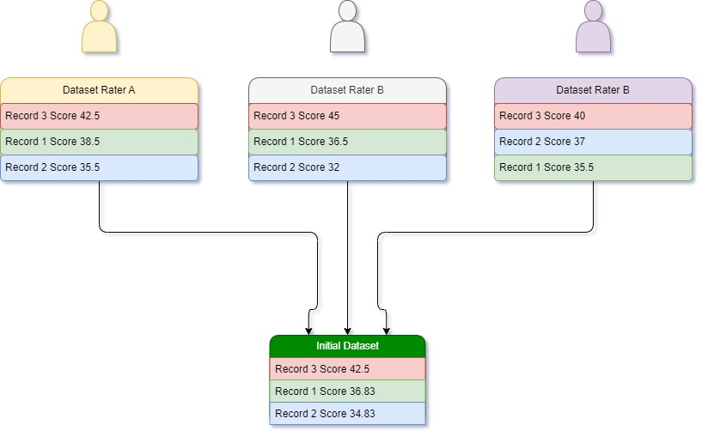This mean value represented the consolidated rating derived from the collective evaluations of all three raters for that particular supermarket.

Figure 4: Combined Dataset Creation for a group

1. **Foundational dataset creation**

* The process described above was then repeated five more times with different participants and different supermarket data each time
* Merging all the five generated datasets resulted in the creation of the foundational dataset used in for the synthetic data generation
* 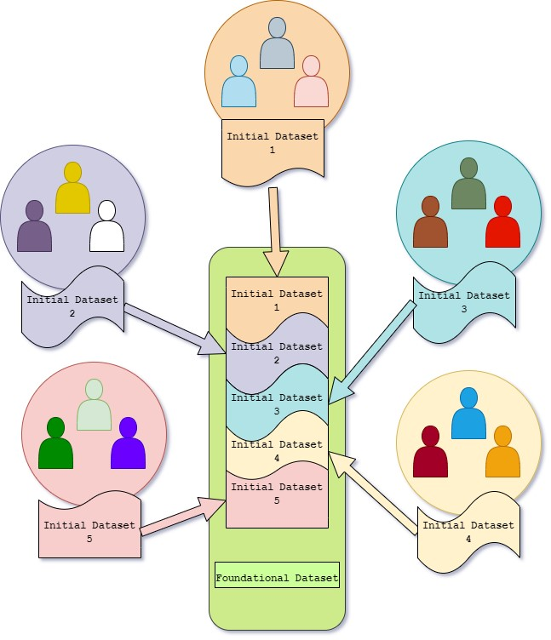The merging of the five datasets containing the mean ratings formed the foundational dataset, capturing aggregated assessments that balanced out individual biases or variations among the raters.

Figure 5: Foundational Dataset Creation

This iterative and adaptive rating process ensured that the foundational dataset's initial creation was robust and reflective of multiple perspectives, leveraging sequential evaluations and dynamic adjustments to refine the dataset's quality and reliability for subsequent analyses or machine learning model training.

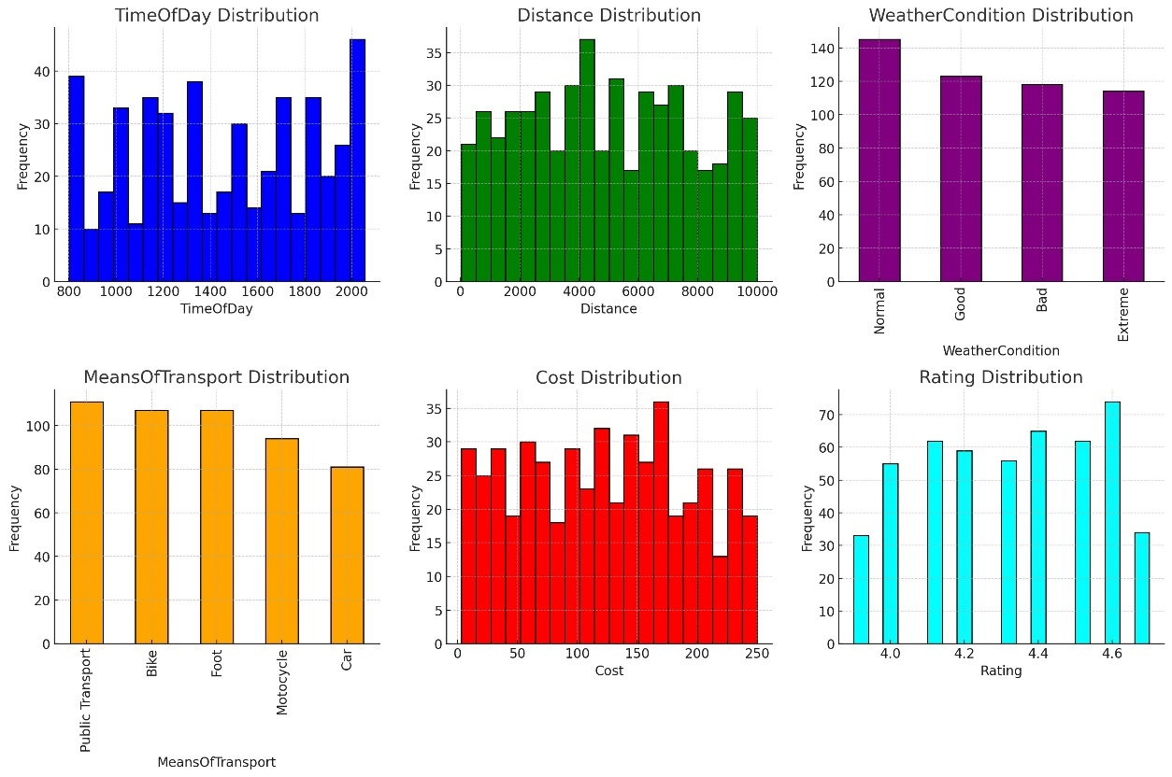The feature distribution of the dataset can be seen below.

Figure 6: Feature Distribution of the Dataset

As seen in the distribution graphs all the features are fairly even distributed resulting in a highly balanced dataset.

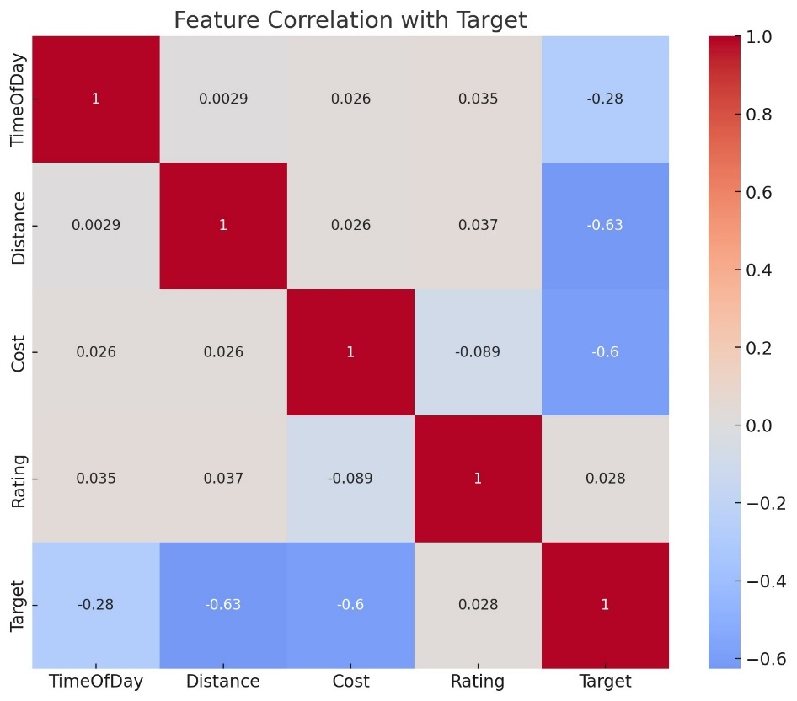Implementing A correlation matrix was created to understand the relationships between different variables. The key findings are:

Figure 7: Correlation Matrix

* **Rating** has a very low positive correlation with the target (0.028), indicating that changes in ratings have little to no linear relationship with the target.
* **TimeOfDay** shows a moderate negative correlation with the target (-0.279), suggesting that as the time of day increases, the target tends to decrease.
* **Cost** has a strong negative correlation with the target (-0.600), indicating that higher costs are associated with lower target values.
* **Distance** shows the strongest negative correlation with the target (-0.627), suggesting that longer distances are strongly associated with lower target values.

Analyzing , the scatter plot between distance, cost and the score of the supermarket also results in the further findings:

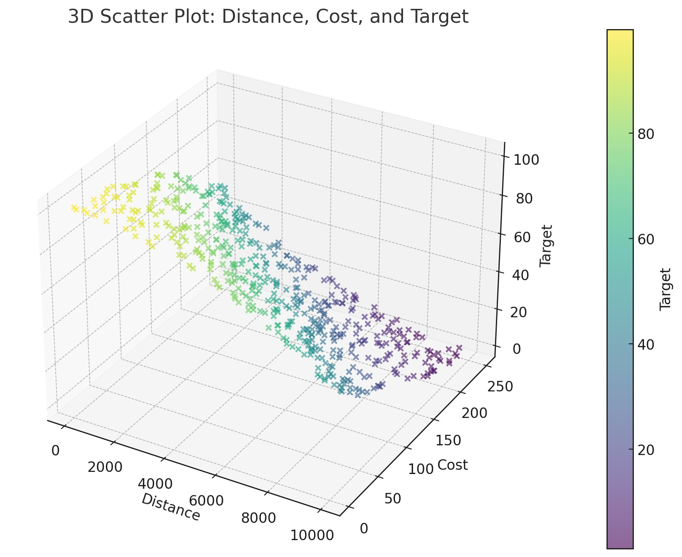

Figure 8: 3D Scatter Plot between Distance, Cost and Target

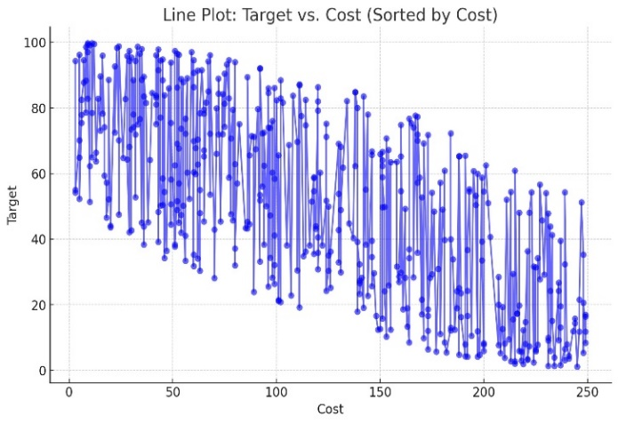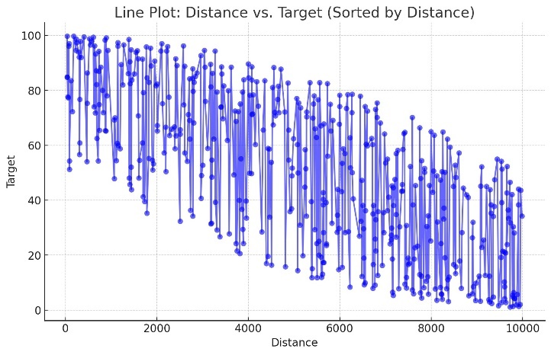We arrive to the same conclusion inspecting the diagrams between Distance-Score as well as Cost-Score, as seen below:

Figure 10: Line Plot Cost - Target

Figure 9: Line Plot Distance - Target

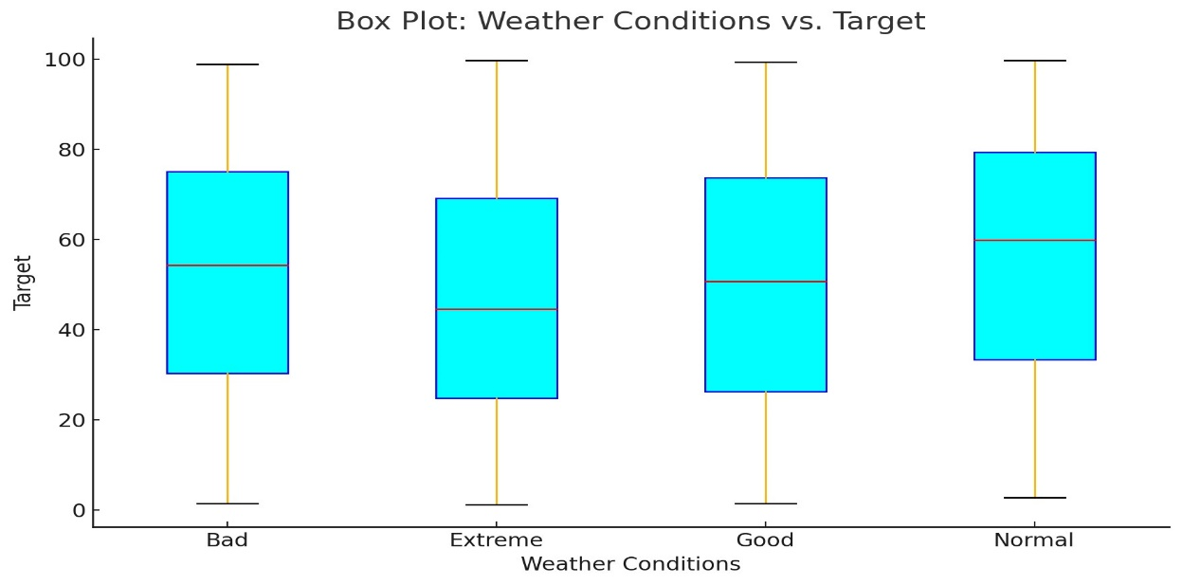Another interesting finding arises when we analyze the affect of the weather conditions to the score of the supermarket using box-plots:

Figure 11: Box Plot Weather Conditions - Target

This visualization suggests that better weather conditions are generally associated with higher target outcomes.

* **Extreme Weather**: Displays a wide range of target values with significant variability.
* **Bad Weather**: Generally lower target values compared to other weather conditions, indicating that adverse weather may negatively impact the target outcome.
* **Normal Weather**: Shows moderate target values with less variability compared to extreme weather.
* **Good Weather**: Associated with higher target values and less variability, suggesting favorable weather positively influences the target outcome.

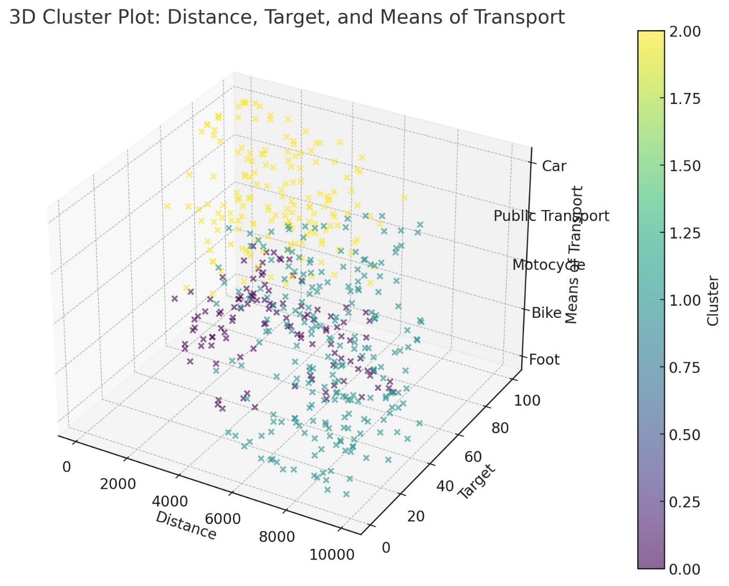Some really interesting insights arise when we perform clustering using the KMeans algorithm using Distance, Score and the means of transport. Three distinct clusters can be extracted each with their own characteristics:

Figure 12: 3D Scatter Plot Distance - Target - Means of Transport

1. **Cluster 0**:

* **Distance**: Short to moderate (mean: 3106.59)
* **Target**: High (mean: 71.46)
* **Means of Transport**: Predominantly on foot (mean: 0.39)

1. **Cluster 1**:

* **Distance**: Longest (mean: 7708.95)
* **Target**: Lowest (mean: 26.17)
* **Means of Transport**: Primarily uses bikes and motorcycles (mean: 1.91)

1. **Cluster 2**:

* **Distance**: Short to moderate (mean: 3152.18)
* **Target**: High (mean: 70.67)
* **Means of Transport**: Predominantly uses public transport and cars (mean: 3.12)

**Cluster 0 and Cluster 2** have similar distance and target means but differ significantly in their means of transport. Cluster 0 is primarily on foot, while Cluster 2 uses public transport and cars.

**Cluster 1** represents consumers with the longest distances and the lowest target values, primarily using bikes and motorcycles.

Finally extracting the correlation of cost to the score of the supermarket as weather conditions change we arrive to the conclusion that, although cost always seem to have a strong negative correlation to the score of the supermarket suggesting that higher cost supermarkets result in lower scores, the cost becomes less relevant the worse the weather gets. This conclusion ties to our previous findings that as the weather worsens, other factors play a more crucial role when picking the ideal supermarket for grocery shopping.

|  |  |
| --- | --- |
| Weather condition | Correlation of Cost to Score |
| Good | -0.727401 |
| Normal | -0.708640 |
| Bad | -0.655886 |
| Extreme | -0.655376 |

If we add for each weather condition the mean of transport and recalculate the correlation of Cost to Score for each pair we get the following results:

|  |  |  |
| --- | --- | --- |
| Weather condition | Means of Transport | Correlation of Cost to Score |
| Extreme | Car | -0.698002 |
| Extreme | Public Transport | -0.658392 |
| Extreme | Motocycle | -0.609832 |
| Extreme | Bike | -0.473445 |
| Extreme | Foot | -0.462175 |
| Bad | Car | -0.792045 |
| Bad | Public Transport | -0.789436 |
| Bad | Motocycle | -0.755315 |
| Bad | Bike | -0.579421 |
| Bad | Foot | -0.559963 |
| Normal | Car | -0.842332 |
| Normal | Public Transport | -0.859821 |
| Normal | Motocycle | -0.843765 |
| Normal | Bike | -0.762102 |
| Normal | Foot | -0.746648 |
| Good | Car | -0.862175 |
| Good | Public Transport | -0.828518 |
| Good | Motocycle | -0.838762 |
| Good | Bike | -0.794545 |
| Good | Foot | -0.789204 |

From these results it’s easy to deduce that to the consumer the cost of the supermarket, although still shows a pretty strong negative correlation to the score, the correlation get weaker in extreme cases such as when there is extreme weather at the time and the user doesn’t have a mean of transport that can provide him with more protection and coverage against the weather. (ex. Extreme weather and Foot, Bad weather and Bike).

On the contrary, if we now extract the same combination matrix but this time calculating the correlation between the distance and the score we arrive to the following results:

|  |  |  |
| --- | --- | --- |
| Weather condition | Means of Transport | Correlation of Distance to Score |
| Extreme | Car | -0.727564 |
| Extreme | Public Transport | -0.739902 |
| Extreme | Motorcycle | -0.780223 |
| Extreme | Bike | -0.887362 |
| Extreme | Foot | -0.879973 |
| Bad | Car | -0.621234 |
| Bad | Public Transport | -0.675332 |
| Bad | Motorcycle | -0.712345 |
| Bad | Bike | -0.723364 |
| Bad | Foot | -0.739902 |
| Normal | Car | -0.647653 |
| Normal | Public Transport | -0.646562 |
| Normal | Motorcycle | -0.650201 |
| Normal | Bike | -0.739321 |
| Normal | Foot | -0.759090 |
| Good | Car | -0.428742 |
| Good | Public Transport | -0.454421 |
| Good | Motorcycle | -0.438908 |
| Good | Bike | -0.709090 |
| Good | Foot | -0.760921 |

As expected we come the opposite conclusions from the one calculating the correlation between Cost and Score. This time, although distance always seems to have a strong correlation to how high a score of a supermarket is, with higher scores being granted to nearer supermarkets, we note higher correlation based on the mean of transport of the user, with Foot and Bike always making distance keep a really high correlation regardless of the weather conditions. Furthermore, in more favorable weather conditions, when the consumer uses a mean of transport that does not have distance restrictions the correlation seems to drop to relative low values, compared to a 50% decrease with the not favorable condition counterparts.

The analysis done above demonstrates the complex nature of the recommendation algorithm suggesting that a simple cost function would have not been enough to enough to tackle the problem. Instead we opt for a more robust and sophisticated approach which can handle multiple layers of decision making and come up with an accurate score to correctly mimic how a real world person would make his decision when grocery shopping, with the different variables present to them at that time.

## 5.3 Training/Testing Dataset Creation using Synthetic Data generators

In order for our recommendation model to be trained properly resulting in accurate and well justified recommendations we needed large volumes of data. This would ensure that the training accuracy for our model is high enough for it to be ready to make calculated recommendations when present with real world scenarios.

### Synthetic data generation

Although our foundation dataset was relatively large, compromised of 500 records, it would have to be far larger than that if we would want our model to mimic a multi-factored human decision making process when it comes to choosing the best destination for grocery shopping. Therefore, in our research we would have to size-up our dataset while maintaining it’s unique characteristics of capturing multiple individuals view and thought process, measured through the scoring procedure, when coming to making up their decisions. In order to achieve our goal we took advantage of synthetic data generators and more specifically, the well established Mostly AI synthetic data generation application. Mostly AI offers a user friendly UI and uses advanced

### Mostly AI generation process

The process of using the Mostly AI platform for synthetic data generation is pretty straightforward. We first upload the Foundational Dataset created in the previous steps in the platform. The dataset will be used to train an AI model making it an expert analyzing the dataset and creating data that mimic the properties of the original. After the original dataset is uploaded and analyzed we start a synthtetic dataset generation asking from the model to generate 1500 rows. This new dataset combined with the foundational one compose the training dataset of 2000 rows used from our model for training. The process can be seen in the diagram below.

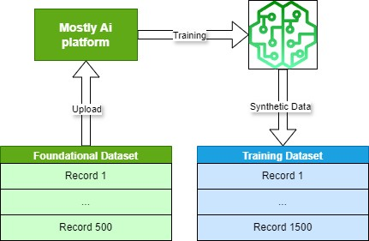

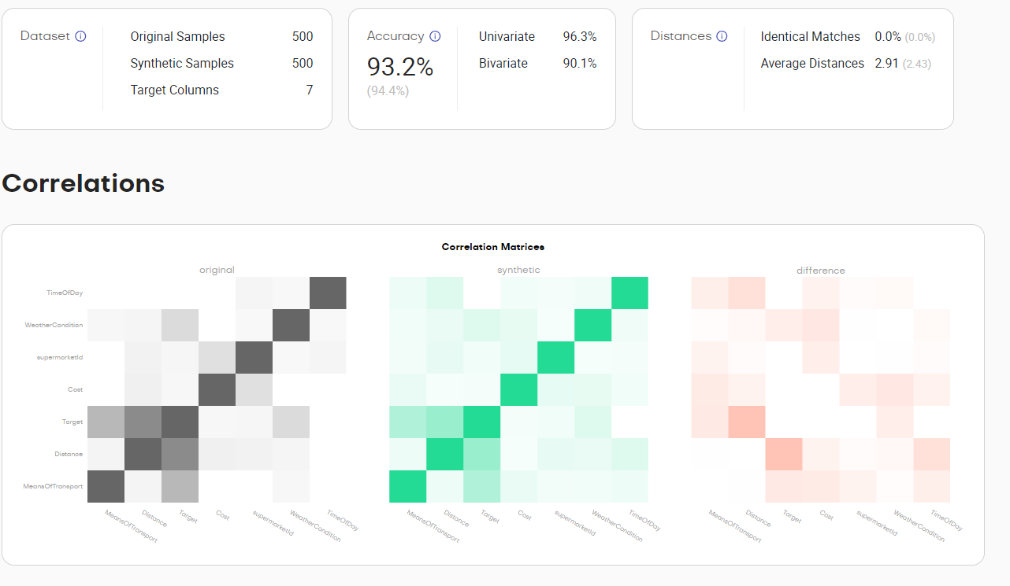Ensuring that the generated data is as close and accurate to our foundational dataset records is key for making sure the final dataset is not only generated from actual real world data but also captures the decision making process of the human logic. The metrics for the dataset generated can be seen in the following report provided by the mostly AI platform.

Moreover the data distribution report is the following for the synthetic dataset.

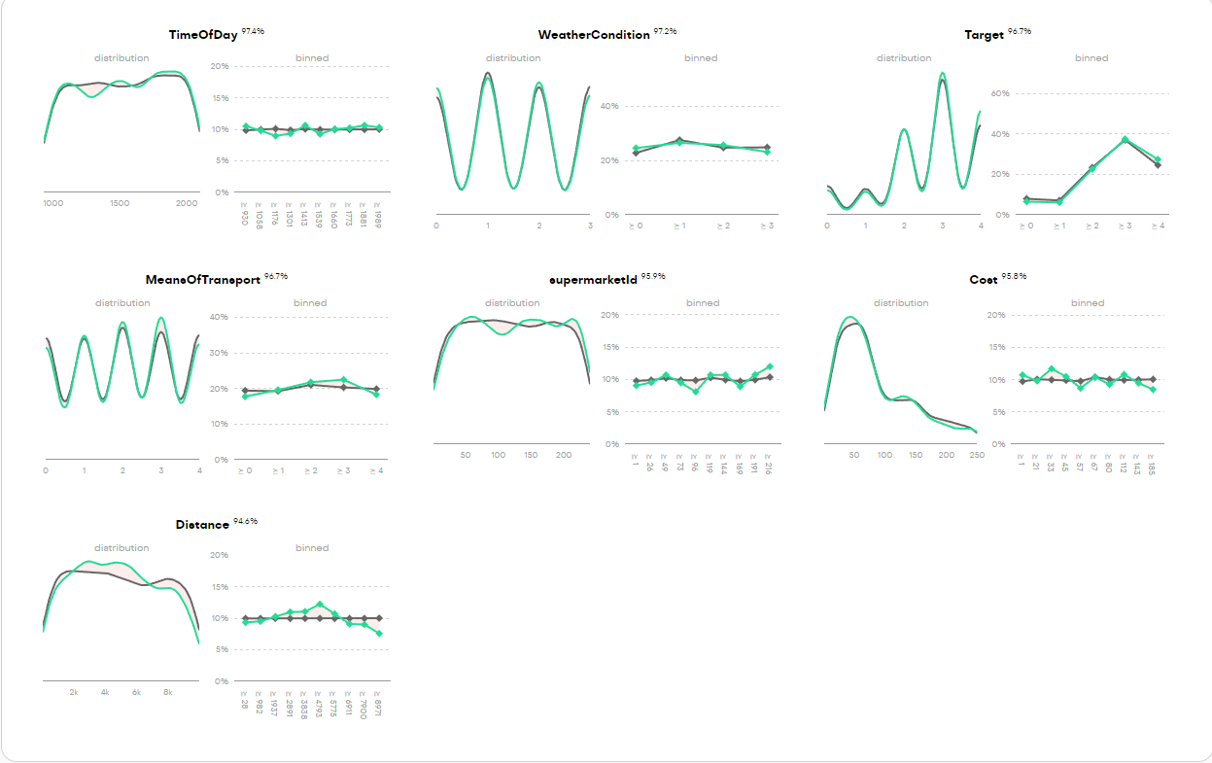

In order to check such characteristics we not only scanned the dataset records one by one for anomalies or data that seemed out of the ordinary, correcting potential out of place records using various excel. python and big data analysis techniques

# 6. Database

The database is the core infrastructure supporting the location-based customer support application. It enables efficient storage, retrieval, and analysis of data to deliver personalized recommendations to users. This section outlines the database’s structure, focusing on the main entities and relationships, and provides details on how data is collected and managed using web scraping techniques.

## 6.1 Technologies used

### PostgreSQL overview

PostgreSQL serves as the backend database for this application due to its scalability, robustness, and support for geospatial queries. PostgreSQL’s support for advanced indexing and data types, including geospatial data via the PostGIS extension, makes it ideal for this application, which relies heavily on location-based services. Key features of PostgreSQL that are leveraged in the application include:

* **PostGIS Geospatial Queries**: Used for efficiently querying nearby supermarkets based on the user's location.
* **ACID Compliance**: Ensures reliable transaction management, preserving data integrity.
* **Advanced Data Types**: Supports arrays, JSON, and other complex data types required for flexible storage of structured and unstructured data.

### pgAdmin overview

pgAdmin is the most popular and feature-rich tool for PostgreSQL database management. It allows users to interact with their databases through an intuitive graphical interface, making it ideal for both novice and advanced users. Key features of pgAdmin include:

* **Comprehensive Graphical Interface**: Provides a user-friendly interface for managing tables, views, functions, and triggers.
* **SQL Query Tool**: Offers a powerful SQL query editor for running ad-hoc SQL queries, making it easy to interact with the database without needing to write complex code.
* **Data Import/Export**: Supports importing and exporting data to and from CSV, Excel, or other formats.
* **Database Monitoring**: pgAdmin comes with tools to monitor database activity, resource consumption, and performance.

More importantly, since we are dealing with large volumes of data in our database pgAdmin was especially preferred for its ability to bulk import data with its built in Bulk API process

## 6.2 Database structure

The database is composed of multiple interconnected entities, each playing a specific role in storing and processing the data needed for the recommendation engine. The design includes core entities such as products, supermarkets, user information, and a historic tracking system for recommendations. Below, we describe the key entities, their fields, and their roles in the system.

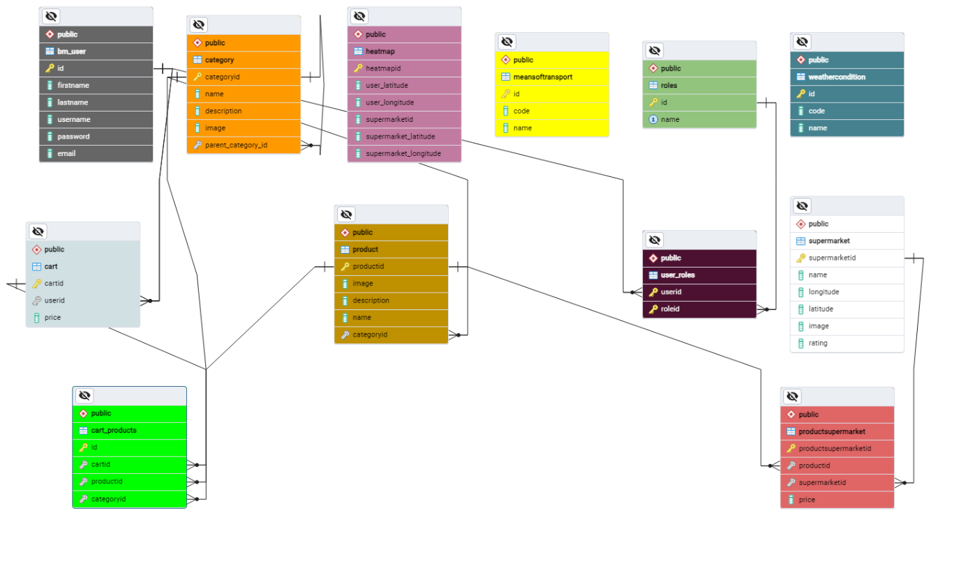

### Product

The product table is a central entity that stores information about all available products in the system. Each product in the database is not tied to a specific supermarket but can appear in multiple supermarkets with different prices.

* **Fields**: productid (Primary Key), name, description, image, categoryid
* **Purpose**: This table holds generic product details such as names, descriptions, and images. Each product can be linked to different supermarkets through the productsupermarket table.

### ProductSupermarket

* **Fields**: productsupermarketid (Primary Key), productid (Foreign Key), supermarketid (Foreign Key), price
* **Purpose**: By storing product-supermarket relationships, this table allows the application to deliver accurate price comparisons across different supermarkets, giving users location-based, real-time shopping recommendations.

### Supermarket

The supermarket table contains information about each supermarket, including its name and geographic coordinates. This data is critical for identifying which supermarkets are near the user’s current location.

* **Fields**: supermarketid (Primary Key), name, longitude, latitude, image, rating
* **Purpose**: The geographic data stored in this table is used in location-based queries to determine which supermarkets are nearby and to provide geolocation-based recommendations to the user.

### Category

The category table classifies products into categories. Categories are organized hierarchically, with support for parent-child relationships.

* **Fields**: categoryid (Primary Key), name, description, image, parent_category_id
* **Purpose**: Categories are used to filter and organize products. This hierarchical structure allows for better navigation and product discovery within the application.

### Cart and Cart_Products

The cart and cart_products tables store information about user shopping carts and the products they contain.

* **Cart Fields**: cartid (Primary Key), userid (Foreign Key), price
* **Cart_Products Fields**: id (Primary Key), cartid (Foreign Key), productid (Foreign Key), categoryid
* **Cart_Products Fields**: id (Primary Key), cartid (Foreign Key), productid (Foreign Key), categoryid

### User and User_Roles

The bm_user table stores user information, while the user_roles table defines the roles associated with each user, controlling access and permissions within the system.

* **bm_user Fields**: id (Primary Key), firstname, lastname, username, password, email
* **user_roles Fields**: userid (Foreign Key), roleid (Foreign Key)
* **Purpose**: These tables handle user authentication and role-based access control. Different roles allow for varying levels of access, ensuring that users can only perform actions allowed by their role.

### WeatherCondition

The weathercondition table tracks current weather conditions, which can influence shopping recommendations. For example, bad weather may prompt users to visit closer supermarkets.

* **Fields**: id (Primary Key), code, name
* **Purpose**: By integrating real-time weather data into the recommendation engine, the system can account for external factors that might affect a user's decision to travel to a specific supermarket.

### MeansOfTransport

The meansoftransport table stores information about the available transportation options for users (e.g., car, walking, bike), which impacts the recommendation engine's decision-making process.

* **Fields**: id (Primary Key), code, name
* **Purpose**: Depending on the user's mode of transport, the system may recommend supermarkets that are more accessible based on distance or transport efficiency.

### Heatmap

The heatmap table functions as a historic tracking data table, recording previous user recommendations and their geographic context. This data allows the system to analyze which supermarkets have been recommended most frequently within specific areas, providing useful insights into user behavior and recommendation trends. The previous trends are also available to the end user.

* **Fields**: heatmapid (Primary Key), user_latitude, user_longitude, supermarket_latitude, supermarket_longitude
* **Purpose**: This table tracks the geographic locations of both users and supermarkets at the time of a recommendation. By aggregating this data, the system can generate analytics that reveal the most frequently recommended supermarkets in a given area, helping to refine the recommendation algorithm further.

## 6.3 Queries for Data Retrieval and Analytics

Several SQL queries are integral to retrieving data from the database for both user-facing functionalities and backend analytics. These queries leverage PostgreSQL’s geospatial capabilities to efficiently handle location-based services.

### Query examples



This query retrieves products, supermarkets, and the corresponding prices for items that are located within a specified radius of the user's location. The query uses **PostGIS** functions to calculate the distance between the user's location and supermarkets, filtering the results to show only nearby stores that stock the requested products. Its main purpose is to enable the application to suggest nearby supermarkets that stock the products on a user's shopping list, along with the respective prices. It is crucial for providing real-time recommendations that are personalized based on the user's location and shopping preferences.



This query is used to analyze which supermarkets have been recommended most frequently in a given geographic area, based on historical data stored in the heatmap table. It counts the number of times each supermarket has been recommended and tracks the locations of users and supermarkets. Its main purpose is to help the system identify trends in supermarket recommendations within a specific area. By counting recommendations and associating them with user and supermarket locations, the system can generate insights into which supermarkets are most popular or effective in specific regions. This information can be used to improve the recommendation algorithm, provide business intelligence for supermarket operators. give the end user a glimpse of what previous users similar to his situation were recommended to and help admin operators identify possible trends among the supermarkets.

## 6.4 Collecting and importing large volumes of real world data

To ensure the consistency and the quality of the UX aspect of the application it was crucial to mimic real world aspects and volumes of data as closely as possible. To accomplish this several data gathering and engineering techniques were advised resulting in more than 4000 records split among multiple tables of real world anonymized data

### Gathering Data Using Web Scraping

The data required for populating the product, supermarket, and productsupermarket tables was collected using web scraping techniques. Specifically, product data from the **Sklavenitis** website was scraped to gather information about more than 3,000 products.

### Tools Used for Web Scraping

For the web scraping process, I used the **Open Web Scrapper** tool. This browser extension enabled efficient extraction of product data from the Sklavenitis website, including product names, prices, and categories. The extraction process involved around collecting html tags with specific html properties using a tree structure seen below and exporting the in excel files.

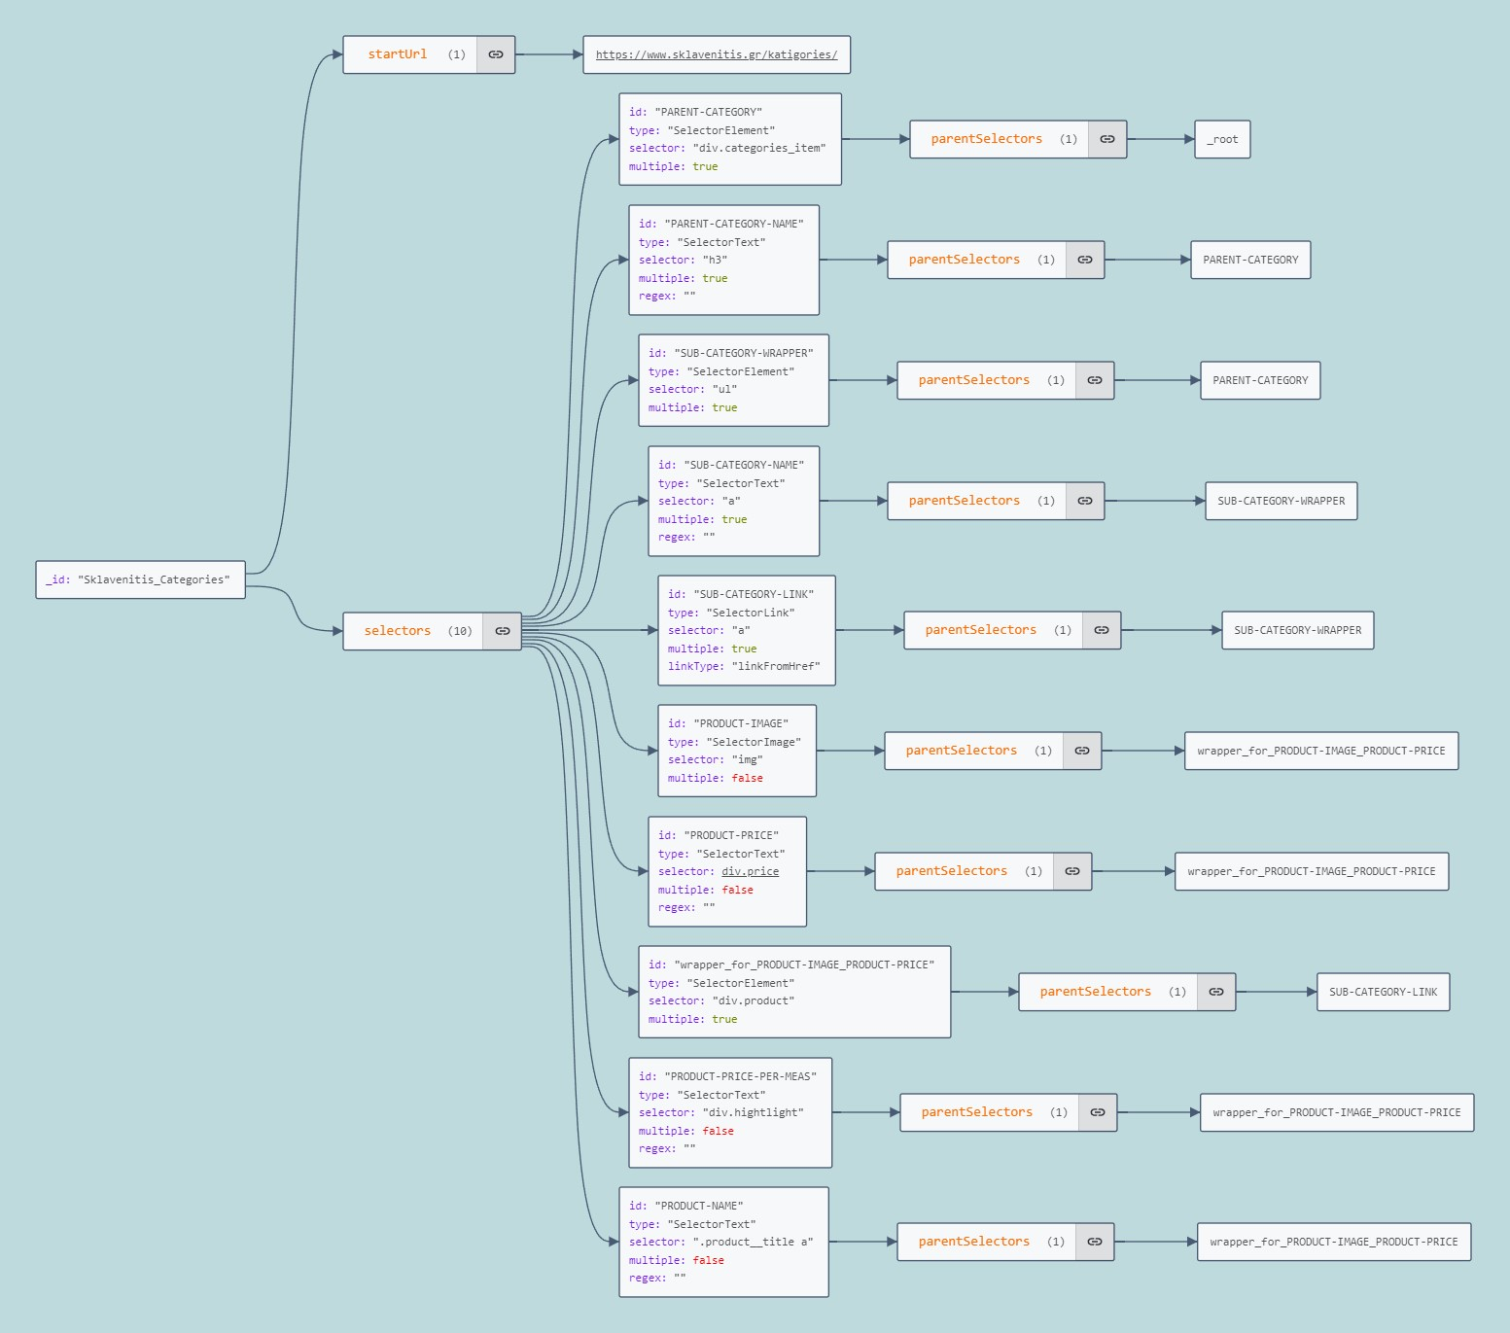

### Data Engineering

Once the raw product data was collected, it needed to be processed and structured for use in the database. Using **Excel** and Python, I applied various data engineering techniques to clean the data and prepare it for import into PostgreSQL.

The following Python script was used to generate the productsupermarket table by creating combinations of products and supermarkets, each with a randomly assigned price:



This script populated the **productsupermarket** table with over 3,000 product-supermarket combinations, each with a unique price, making the data ready for integration into the recommendation engine.

# 7. Backend Architecture

The backend architecture of this location-based customer support application is designed as a distributed system, involving both a Node.js server and a Flask (Python) server. This dual-server ecosystem enables efficient communication between the application’s frontend, the database, and machine learning models to provide real-time, location-sensitive recommendations for users based on their grocery cart and current conditions like weather or distance.

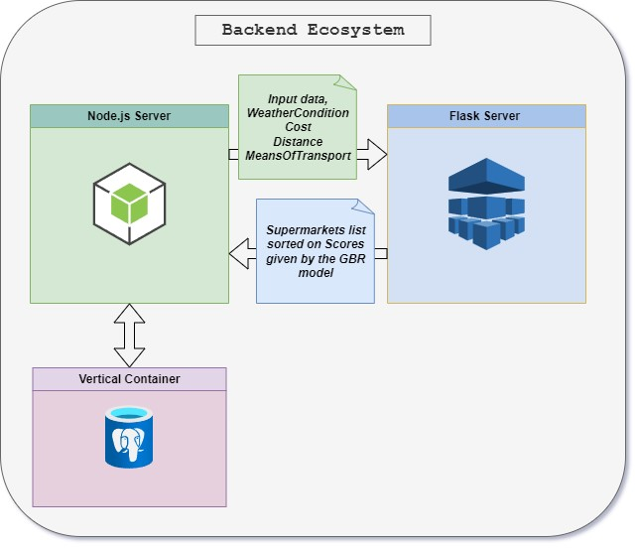

## 7.1 Node.js Server

The **Node.js server** plays a central role in managing the interaction between the user interface and the database. Built on an asynchronous, event-driven architecture, Node.js provides high efficiency for managing multiple simultaneous connections, which is crucial for a real-time recommendation system like this. Node.js processes user requests by fetching data from the database, managing data inputs such as the user's grocery list, and formatting the data for further analysis.

In this system, when a user adds groceries to their shopping cart, the Node.js server retrieves location-sensitive data, including the availability and pricing of these items across various supermarkets. It communicates with the database (PostgreSQL) to ensure that all data points such as prices, proximity, and stock are up-to-date. After gathering the necessary data, Node.js formats it into a structured form that the Flask server can use for prediction.

The efficiency of Node.js allows the system to handle multiple data requests concurrently, making it ideal for applications where real-time data processing and low-latency responses are key performance indicators. Its non-blocking architecture ensures that the server can continue to process other requests while waiting for the database or other components to respond.

### Structure: Routes, Controllers, and Middleware

The backend server in this application follows a **modular architecture** that separates concerns and ensures maintainability, scalability, and efficient handling of requests. This architecture is built around three key components: **Routes**, **Controllers**, and **Middleware (MDW)**. This structure enables clear organization of logic, simplifies debugging, and allows for easy feature updates or expansions.

### Defining the API Endpoints

In the **Node.js** environment, routes are essential for defining the API endpoints that handle incoming requests from the frontend. The routes map the specific URLs and HTTP methods (GET, POST, PUT, DELETE) to the appropriate functions that process these requests.

### Authentication Routes and Controllers

The authentication routes enable users to sign up and sign in securely.

* **Route: /api/auth/signup**

Registers a new user by collecting their username, email, and password.

* **Route: /api/auth/signin**

Allows users to log in by verifying their credentials and, upon success, returns a JWT token for future authenticated requests.

**Authentication Controller Logic**

The authentication controller is responsible for managing user authentication through two main actions: signup and signin. The logic focuses on securely handling sensitive data such as passwords and tokens, ensuring safe access to the system.

**1. Signup Process**

* Password Hashing: When a user signs up, the bcrypt library is used to hash the password before storing it in the database. Password hashing is crucial for security, as storing plain-text passwords can expose users to risks if the database is compromised. The hashing algorithm produces an encrypted representation of the password that is difficult to reverse-engineer.
* Database Insertion: After hashing, the user’s credentials are inserted into the database using SQL queries. The controller uses the pg library to communicate with a PostgreSQL database, ensuring efficient data handling.

**2. Signin Process**

* Password Validation: During login, the entered password is compared with the stored hash using bcrypt.compareSync(). This function ensures that the entered password matches the one stored in the database.
* JWT Token Generation: If the login is successful, the jsonwebtoken (JWT) library is used to generate a token containing the user's ID. This token is encoded using a secret key and contains an expiration time (24 hours in this case). The generated token is crucial for stateless authentication:
  + Stateless Authentication: Once a user logs in and receives a JWT, they don’t need to re-authenticate until the token expires. The server doesn't store session data; instead, the token is passed with each request. This improves scalability and efficiency, particularly in distributed systems.

**Key Programming Techniques:**

* Asynchronous Database Operations: The controller uses async SQL queries with pg, ensuring non-blocking operations to handle multiple user requests simultaneously.
* Security Best Practices: By using bcrypt for password hashing and JWT for authentication, the system is built to prevent common security threats such as brute-force attacks and session hijacking.

### User edit Routes and Controllers

The user edit routes allow users to modify their account details (username and email) and fetch their current details.

* **Route: /api/editUserDetails**

**Lets a user update their username and/or email.**

* **Route: /api/getUserDetails**

Retrieves the current user’s details based on the user's token.

**Edit Controller Logic**

The edit controller handles user profile updates and retrieval, with a focus on database consistency and uniqueness checks.

1**. Edit User Details Process**

* Conflict Resolution: Before updating a user’s details, the controller first checks for conflicts. This is done by querying the database to ensure no other users share the same username or email. If a conflict is detected, the update is rejected with a meaningful message.
* Dynamic SQL Query Building: The controller dynamically builds the SQL query based on which fields (username, email) are being updated. This allows flexibility in partial updates, avoiding unnecessary overwrites.

**2. Get User Details Process**

* Token-based Authentication: When retrieving user details, the controller uses the user’s token to securely identify the user making the request. This ensures that each user can only access their own information.

**Programming Techniques:**

* Dynamic SQL Queries: By constructing SQL queries dynamically based on the provided data, the system avoids redundant database operations and ensures only relevant fields are updated.
* Asynchronous Operations: Like other controllers, it relies on async queries for non-blocking performance.

### Cart Management Routes and Controllers

The cart routes manage all operations related to a user’s shopping cart, such as saving, retrieving, deleting, and updating items.

* **Route: /api/saveCart**
  + Saves a new cart and its items for the user.
* **Route: /api/getCartProductsUserId**
  + Retrieves all products in the user’s cart based on their user ID.
* **Route: /api/deleteCart**
  + Deletes the user's cart and its associated products.
* **Route: /api/updateCart**
  + Updates the user's cart, allowing modifications to items or categories.

**Cart Management Controller Logic**

The cart controller manages cart operations, ensuring data integrity and seamless user interactions with their shopping carts.

**1. Saving a Cart**

* Multi-Table Inserts: When a user saves their cart, the controller inserts cart data into two tables: the main Cart table and the cart_products table that links products to carts. This relational approach ensures that each cart can have multiple products and can scale well as more users save items.

**2. Retrieving a Cart**

* Joins Across Multiple Tables: To retrieve cart products, the controller performs SQL joins across bm_user, cart, product, and category tables. This allows a comprehensive view of the user's cart, including product details, categories, and images.

**3. Updating a Cart**

* Delete-Insert Strategy: To update a cart, the controller first deletes all existing entries in the cart_products table for the given cart ID, then re-inserts the updated items. This approach ensures that the cart is fully synchronized with the user's latest modifications.

**Programming Techniques:**

* Joins for Data Aggregation: By using SQL joins, the controller efficiently aggregates data from multiple tables, providing a full view of the user’s cart in a single operation.
* Transaction Management: The controller likely operates within database transactions to ensure that if one operation (like inserting products) fails, the entire operation is rolled back, preventing partial data corruption.

### Recommendation Routes and Controllers

**Routes Overview**

The main store routes handle operations related to supermarket products and recommendations.

* **Route: /api/recommendation**

Generates personalized supermarket recommendations based on the user's cart, location, weather, and transportation method.

* **Route: /api/heatmap**

Provides heatmap data showing supermarket activity near the user's location.

**Recommendation Controller Logic**

The recommendation controller processes user input (such as cart items and location) to generate recommendations for the best supermarkets. This involves complex logic to optimize user experience and ensure accurate results.

**1. Recommendation Generation**

* Distance Calculation: The controller first calculates the distance between the user's location and nearby supermarkets using a formula to compute the distance from latitude and longitude values. This ensures the recommendations are proximity-based.
* Product Matching: The controller matches the products in the user's cart with the products available at nearby supermarkets, then calculates which supermarkets offer the most items from the cart. The logic here involves filtering and grouping products by supermarkets.
* Cost Calculation: Once a matching supermarket is found, the total cost of the cart at that supermarket is calculated using helper functions. This allows users to receive recommendations for the cheapest option available.

**2. Data Formatting for Machine Learning**

* formatSupermarketData: Before sending the recommendation data to the external machine learning server, the controller formats it using helper functions that take into account weather, transportation, and time of day. The formatSupermarketData function converts raw data into a structured format that the machine learning model can process. This structure includes:
  + **Weather condition codes**
  + **Transportation method codes**
  + **Time of day and distance**

In the recommendationController, the process of generating data for the machine learning (ML) model involves several steps, each designed to extract relevant features from user data (such as cart contents, location, and preferences) and format it in a way that the ML model can process. The model then predicts the best supermarket for the user based on various factors like cost, distance, weather, and transportation. Below is a detailed breakdown of the entire process leading up to the final data being fed into the ML model.

**Step-by-Step Breakdown of the Data Processing Pipeline**

**1. Retrieving Nearby Supermarkets**

The process begins by identifying supermarkets near the user based on their location. The user’s latitude and longitude are used to find supermarkets within a specific radius (e.g., 10 km). This is done through a geospatial query using PostgreSQL's earth-distance extension.

* Geospatial Query: The query finds supermarkets that are close to the user’s location. The query also retrieves product availability at each supermarket for the items in the user’s cart.
* Distance Calculation: After fetching nearby supermarkets, the getDistanceFromLatLonInKm function calculates the exact distance between the user and each supermarket in meters. This distance is crucial for determining how far a user must travel to each store.



**2. Filtering and Matching Products with Supermarkets**

Once the nearby supermarkets are identified, the system checks which products from the user’s cart are available in these supermarkets. This involves matching the product IDs from the user’s cart with the products stocked by the supermarkets.

* Product Matching: The controller filters the results to identify which supermarkets stock the items from the user's cart. This is essential because the goal is to recommend a supermarket where the user can purchase most, if not all, of their desired items.
* Grouping by Supermarket: Products are grouped by supermarket so that the controller can later evaluate how well each supermarket matches the user’s shopping list.

**3. Calculating Cart Cost for Each Supermarket**

For each supermarket, the controller calculates the total cost of the cart by summing up the prices of the items that are available at that supermarket. This calculation is done using the **calculateCostOfCart** helper function:



Quantity-based Pricing: The function multiplies the price of each item by the quantity specified in the user’s cart. This gives the total cost of purchasing the full cart from a specific supermarket.

Filtering Supermarkets by Cart Match: The controller also filters supermarkets based on how well they match the user’s cart. Only supermarkets that stock all or most of the items are considered for final recommendations.

**4. Formatting Data for the ML Model**

Once the controller has calculated the cart costs and distances for each supermarket, it formats the data to prepare it for input into the external ML model. The **formatSupermarketData** function is used to convert the supermarket data into a structured format that includes various features, such as weather conditions, means of transport, and time of day.

**Key Features Prepared for the ML Model:**

* **Supermarket Name**: The name or identifier of the supermarket.
* **Distance**: The calculated distance between the user and the supermarket.
* **Cost**: The total cost of the cart at each supermarket.
* **Rating**: The rating of each supermarket (if available).
* **Weather Condition**: A numerical code representing the current weather (e.g., rain, thunderstorm, sunshine).
* **Means of Transport**: A numerical code representing how the user plans to travel (e.g., walking, biking, driving).
* **Time of Day**: Encoded as a numerical value representing the current hour and minute.



**Time of Day:** The controller encodes the current time by extracting the hour and minute, which might influence the model's prediction.

**Weather Condition**: The weather is categorized into several types (e.g., sunny, rainy, thunderstorm) and is represented by a numerical code.

**Means of Transport**: The user’s selected means of transportation (walking, car, bike) is also encoded as a number, which may influence the model’s decision. For example, certain supermarkets may be more or less accessible based on the user’s transportation method.

**5. Sending Data to the ML Model**

Once the data is formatted, it is sent to an external Python server running a **machine learning model**. This model evaluates the supermarkets based on the input features and provides a ranked list of recommendations.

* **Asynchronous Request**: The controller uses the **fetch** API to make an asynchronous HTTP POST request to the Python server. The ML model on the Python server predicts the best supermarket based on the input data and returns a sorted list of recommendations.



**6. Receiving and Sorting the ML Model Output**

The output from the ML model consists of a scored list of supermarkets. The scores reflect how well each supermarket matches the user’s needs based on factors like cost, distance, and external conditions (weather, transport).

* **Sorting Recommendations**: The list of recommendations is sorted based on the scores provided by the model. The controller then selects the top recommendation (the supermarket with the highest score) and returns it to the frontend.



**7. Final Response to the User**

The final result returned to the frontend includes the best supermarket, as well as additional options like the **nearest** supermarket and the **cheapest** supermarket (based on cart cost). These recommendations help users make informed decisions about where to shop.

* **Heatmap Update**: The controller also updates the heatmap by logging the user's interaction with the recommended supermarket, adding the user's location and the supermarket's location to the heatmap data.



**Key Programming Techniques**

* **Data Formatting**: The data fed into the ML model is meticulously formatted using helper functions. This includes encoding categorical variables (like weather and transport) into numerical representations and ensuring that all features are normalized and structured for ML consumption.
* **Asynchronous Fetch Requests**: The controller uses asynchronous fetch requests to communicate with the external Python server, ensuring that the system remains non-blocking and responsive even when making external API calls.
* **Sorting Algorithms**: After receiving the recommendations from the ML model, the controller sorts the results by score and returns the best options to the user. This ensures that users receive the most relevant and optimal supermarket recommendations based on their specific needs.

### Product and Category Management Routes and Controllers

The **itemControllerl.js** file operates as a controller for retrieving product and category data from the database. It handles fetching categories, subcategories, and product details to support the main store routes.

**1. Fetching Parent Categories**

* **Purpose**: Retrieves all parent categories (categories that have no parent themselves) from the database. These categories serve as the primary navigation points for users who are browsing the store.

**SQL Query**: The query looks for categories where the parent_category_id is NULL, indicating that these categories are not subcategories but parent categories.

**Use Case**: This function is triggered when the user opens the main store page to browse product categories.

**2. Fetching Subcategories by Parent ID**

* **Purpose**: Fetches subcategories for a given parent category, allowing users to navigate through hierarchical product groupings. For example, within the "Dairy" parent category, subcategories like "Milk" and "Yogurt" can be fetched.

**SQL Query**: This query retrieves all categories where the parent_category_id matches the given category ID. This allows the system to show users subcategories that belong to a parent category.

**Use Case**: When a user selects a parent category, this function fetches its subcategories for further navigation.

**3. Fetching Items by Category ID**

* **Purpose**: This function retrieves all products within a specific category, such as "Milk" within the "Dairy" category. This allows users to browse through items available in each category.

**SQL Query**: The query selects all products from the Product table where the categoryid matches the specified category. This provides users with a detailed view of the available products within the selected category.

**Use Case**: When a user clicks on a subcategory like "Milk," this function is triggered to retrieve all relevant products.

**4. Fetching Category Details by ID**

* **Purpose**: Retrieves details about a specific category. It’s useful for displaying additional information about a category when a user selects it.

**SQL Query**: The query selects a category by its categoryid and retrieves its details, which can include its name, description, and image.

**Use Case**: This function is used to show category-specific information, such as when the user hovers over or clicks a category for more information.

## 7.2 Middleware in the Backend: JWT and its Implementation

Middleware plays a crucial role in the backend of a web application by processing requests before they reach the main logic or controllers. In our backend system, middleware is used extensively to ensure security, manage user sessions, and enforce data integrity. One of the core middleware implementations in the project is the use of **JWT (JSON Web Token)** for authentication. This section will explain how JWT is used, the flow of JWT-based authentication, and how it is implemented in our code.

### JWT Overview

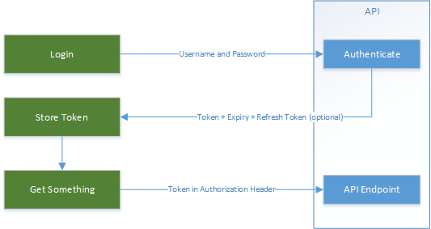**JWT** is an open standard (RFC 7519) used to securely transmit information between two parties (a client and a server) in the form of a **JSON object**. JWT is widely used for **stateless authentication** because it allows the server to authenticate users without maintaining session data for each client. Once a user is authenticated, the server generates a JWT and sends it back to the client. The client then includes this token in every subsequent request, allowing the server to verify the user's identity without needing to track session data.

### Structure of a JWT

A JWT consists of three parts:

1. **Header**: Contains metadata about the token, including the algorithm used for signing it (e.g., HMAC SHA256 or RSA).
2. **Payload**: Contains the claims, which are statements about the user (e.g., their user ID or roles). The payload is usually a base64-encoded JSON object.
3. **Signature**: The signature is generated by hashing the header and payload using the specified algorithm and a secret key. It ensures that the token cannot be altered.

An example JWT looks like this:



Each part is separated by a dot (.), and the payload can be decoded to reveal the claims about the user.

### Usage in Backend

In our backend, JWT is used for **authentication** and **authorization**. Once a user logs in, a JWT is issued, which the client includes in every subsequent request that requires user authentication. The backend verifies the JWT with each request to ensure that the user is authenticated and authorized to access the requested resources.

**Steps in the JWT Process:**

1. **User Login**: Upon successful login, a JWT is created and signed using a secret key. This token is sent to the client.
2. **Client Stores the Token**: The client stores the JWT, typically in the session storage and includes it in the Authorization header of every subsequent request.
3. **Token Verification**: For each request, the server checks the token’s validity, ensuring that it hasn’t expired and that it hasn’t been tampered with.
4. **User ID Extraction**: If the token is valid, the user’s ID is extracted from the payload and attached to the request object for use in downstream controllers.

### ****Implementation of JWT in Backend****

JWT is implemented in our backend using the **authJwtMDW.js** file, which contains the middleware responsible for verifying the JWT provided by the client.

**Token Verification Logic**

The **verifyToken** function is used to verify the JWT token that is sent with each request. This function ensures that only authenticated users can access certain routes. Here’s how it works:



**Breakdown of Key Logic:**

**Extracting the Token**: The middleware first checks if a token is present in the request headers. The token is expected in the x-access-token header. If no token is provided, the server returns a 403 (Forbidden) status with an error message.

**Verifying the Token**: If the token exists, it is verified using the **jsonwebtoken** library. The token is decoded and checked against the secret key stored in your configuration file (authConfig.js). This ensures the token hasn’t been tampered with. If the token is invalid or expired, the server returns a 401 (Unauthorized) status.

**Attaching User Data**: Once the token is successfully verified, the user’s ID is extracted from the decoded token and attached to the req object. This ID is passed along to downstream controllers, allowing the server to identify the user making the request.

**Next Middleware/Controller**: If the token is valid and the user is authenticated, the middleware calls next(), passing control to the next middleware or controller in the request pipeline.

### Other Middleware Implementations in the Project

**Checking for Duplicate Usernames or Emails**

Before creating a new user, the middleware checks whether the username or email is already taken. This middleware is executed during the signup process to prevent duplicate entries.

**Duplicate Check**: This middleware runs two queries: one to check if the username exists and one to check for duplicate emails. If either query returns a result, the request is rejected, and an error message is sent.

**Efficiency**: By preventing duplicate usernames and emails at the middleware level, this implementation ensures that only valid, unique entries are passed along to the signup controller.

### Using Middleware in Routes

The middleware functions (JWT verification and duplicate checks) are imported into the routing files (such as authRoutes.js) and applied to specific routes to protect resources or ensure data validity.

**Example: Applying Middleware in Routes**

In the **index.js** file, the JWT verification and the duplicate check middleware are bundled together and exported for use in the routes:



This middleware is then used in the **authentications** routes:



* **Signup Route**: The checkDuplicateUsernameOrEmail middleware ensures that the username and email are unique before the **signup** logic is executed.
* **Protected Routes**: Any route that requires the user to be authenticated uses the verifyToken middleware to ensure that a valid JWT token is present and the user is authorized.

### Summary of JWT Middleware Workflow

1. **User Authentication**: When the user logs in, a JWT is created and sent to the client.
2. **Token Inclusion in Requests**: The client includes the JWT in the x-access-token header for all subsequent requests.
3. **Token Verification Middleware**: For protected routes, the verifyToken middleware extracts the token, verifies it, and attaches the user's ID to the request object.
4. **Access to Protected Resources**: If the token is valid, the user can access the protected resources or functionality (e.g., viewing their shopping cart or placing an order).

By implementing JWT in your middleware, your application ensures that only authenticated users can access specific resources, creating a secure and stateless authentication system that scales efficiently.

## 7.3 Python Server for Supermarket Recommendations: Gradient Boosting Regressor Model

In the recommendation system architecture, the Python server plays a critical role in providing personalized supermarket recommendations by leveraging a **Gradient Boosting Regressor (GBR)** model. This server, built using the **Flask** web framework, is responsible for receiving data from the Node.js backend, processing it using the machine learning model, and returning the results that inform the user about the best supermarket options. This section details the structure of the Python server, the functionality of the GBR model, and the process by which data is exchanged between the two systems to generate personalized recommendations.

### Python Server Overview

The Python server is designed as a microservice using Flask, a lightweight web framework ideal for handling HTTP requests and running machine learning models in real time. Its primary responsibility is to accept user data (including location, shopping cart contents, weather conditions, and transportation method) from the Node.js backend and return a prediction about the most suitable supermarket based on these inputs.

Key libraries of the Python server include:

* **Flask**: Manages the server’s API, handling HTTP requests and responses.
* **Scikit-learn**: Provides the machine learning capabilities through the use of the **Gradient Boosting Regressor (GBR)** model.
* **JSON**: The format for data exchange between the Node.js server and the Python server, ensuring seamless communication between the two systems.

### Gradient Boosting Regressor (GBR) Model

The Python server’s predictive capabilities rely on the **Gradient Boosting Regressor (GBR)** model, an ensemble machine learning method. GBR constructs a series of weak learners, typically decision trees, and iteratively refines its predictions by minimizing the errors of previous iterations. This method is highly effective for tasks involving complex non-linear relationships, such as supermarket recommendation, where factors like distance, cost, weather, and user preferences interact in intricate ways.

**Why GBR?**

* **Handling Complex Relationships**: The recommendation task requires balancing multiple factors, including proximity, cost, transportation mode, and weather. GBR’s ability to model complex non-linear relationships between features makes it an ideal choice for this task.
* **Robustness to Overfitting**: GBR's iterative process builds a strong predictive model by correcting errors in each step, leading to a more generalizable model that performs well with unseen data.
* **Feature Importance**: One of the advantages of GBR is that it provides insights into feature importance, allowing the system to understand which factors—such as distance or cost—have the greatest influence on the final recommendation.

**Model Training**

The GBR model is trained on a dataset that captures user behaviors and supermarket attributes, such as product availability, prices, and distances from user locations. The training data includes variables such as:

* **Cart cost**: The total cost of the user’s cart at each supermarket.
* **Distance**: The distance between the user and the supermarket.
* **Weather conditions**: Categorical variables representing different weather types (e.g., sunny, rainy, snowy).
* **Transportation method**: The user’s selected means of transport, such as walking, biking, or driving.
* **Time of day**: Used to account for variations in traffic or store availability.

The output of the model is a **score** for each supermarket, indicating how well it matches the user’s preferences and context. The supermarket with the highest score is deemed the most suitable for the user.

### Data Flow Between Node.js and the Python Server

The Python server works in close conjunction with the Node.js backend, which collects and formats user data before sending it to the Python server for prediction. This section details the flow of data and the interactions between the two systems.

**Data Preparation in Node.js**

Before sending data to the Python server, the Node.js server gathers all relevant user information, including:

* **Shopping cart contents**: A list of products and quantities the user wishes to purchase.
* **Location**: The user’s current latitude and longitude.
* **Weather and transport**: Data on the current weather conditions and the user’s chosen mode of transportation.

This data is then structured into a JSON format, which is sent as part of an HTTP POST request to the Python server. An example of the data format is as follows:



### Data Processing in Python

Upon receiving the POST request, the Python server parses the JSON data and prepares it for input into the GBR model. The following steps are performed:

1. **Data Parsing**: The Python server, using **Flask**, retrieves the user data from the request. This data is extracted into a structured format suitable for machine learning inference.
2. **Feature Preprocessing**: Before the data is passed to the GBR model, preprocessing steps are applied:
   * **Scaling and normalization**: Features such as **distance** and **cost** are normalized to ensure that they are on the same scale, preventing any single feature from disproportionately influencing the model’s output.
   * **Encoding categorical variables**: Features like **weather conditions** and **transportation mode** are converted into numerical codes (e.g., 0 for rain, 1 for walking).

The preprocessed data is then fed into the GBR model for prediction.

### Model Prediction and Response

Once the data is processed, the **Gradient Boosting Regressor** generates predictions for each supermarket. The model evaluates factors such as cost, distance, and external conditions (weather, transport), assigning a score to each supermarket based on how well it matches the user’s preferences and context.

**Model Inference**

The model’s inference returns a list of supermarkets, each with an associated prediction score. The Python server formats these results into a JSON object and sends them back to the Node.js server. An example of the response format is shown below:



**Ranking and Final Recommendation**

The supermarkets are ranked based on their scores, with the top-ranked supermarket being the recommended choice for the user. The **Node.js** server receives this ranked list and integrates the recommendation into the user’s interface, providing a personalized shopping suggestion.

### Core Components of the Python Server

**Flask API for Prediction**

The core functionality of the Python server is encapsulated within a Flask API that listens for POST requests at a specific endpoint (e.g., /predict). The server extracts features from the incoming data, processes them using the GBR model, and returns the prediction.



**Model Integration**

The GBR model, trained using **scikit-learn**, is loaded into memory upon server startup and used to make predictions in real-time. The model is stored in a serialized format (using **pickle**) to enable quick loading and inference.



### Preprocessing Logic

The server includes preprocessing logic to ensure that incoming features are properly formatted before being passed into the model. This includes scaling numerical features and encoding categorical ones (e.g., weather and transport mode).

### Benefits of Using a Python Server with GBR

The Python server architecture offers several advantages for managing personalized recommendations:

1. **Decoupling Machine Learning from Business Logic**: By offloading the machine learning computations to a dedicated Python server, the system ensures that the Node.js server can focus on handling business logic and user interactions, while the Python server handles complex computations.
2. **Scalability**: The separation of the machine learning service allows for easier scaling. As the demand for predictions grows, additional Python instances can be deployed to handle increased traffic.
3. **Real-time Recommendations**: The use of a **Gradient Boosting Regressor** enables the system to provide highly accurate, real-time recommendations that adapt to the user's current shopping context.

# 8. Frontend Design

The frontend of the application is designed with a primary focus on user-friendliness and efficiency, ensuring that users can seamlessly browse through a wide array of product categories and create their grocery lists with ease. The goal is to provide a simple yet effective pipeline that allows users to select their desired products and compile their shopping lists as quickly as possible, without compromising on functionality or user experience.

To achieve this, the application employs a minimalist design across all pages, which helps users familiarize themselves with the interface swiftly. By keeping the design clean and intuitive, users are empowered to navigate through the platform without unnecessary distractions, while also enjoying access to advanced features that enhance their overall experience.

Key features such as the search and filter options enable users to quickly locate specific products or categories, streamlining the browsing process. The application also incorporates a navbar that provides easy access to different sections, such as the shopping cart, account management, and help page, further reducing the time required to switch between tasks.

The app's minimalist design is complemented by clear indicators, intuitive icons, and mindful images that represent each feature and product category. Every page is crafted with the user in mind, with simple buttons and accessible text ensuring that the app can be used by individuals with varying levels of technical expertise. Additionally, a chatbot is integrated into the interface, offering real-time assistance and guidance as users navigate the platform. This feature enhances the overall user experience by providing instant answers to questions and offering step-by-step help where needed.

Whether it’s for creating a grocery list, selecting products, or navigating between pages, the application ensures a smooth and enjoyable experience for users. With helpful directions, support features, and an easy-to-understand layout, the app is designed to cater to both novice and experienced users, offering flexibility and speed without compromising on simplicity.

## Home Page

At the top of the page, the **Hero section** displays vibrant images of fresh produce, creating a visually appealing banner that reinforces the theme of shopping for groceries. The hero includes the application’s logo, "BestMarket," which is displayed prominently in the center. This section sets a welcoming tone for the user, highlighting the focus on groceries and related shopping experiences.



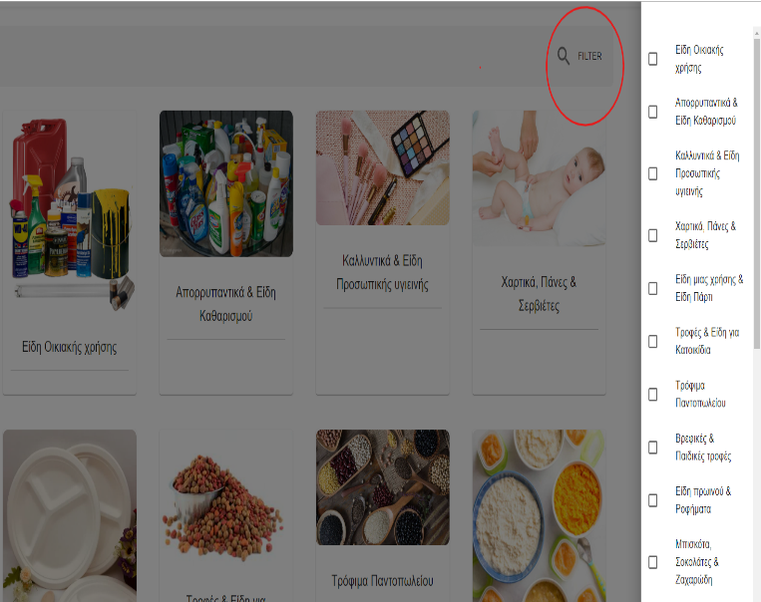The primary focus of the Home Page is the display of **Parent Categories**, which are neatly presented in a card-based layout. Each card represents a different shopping category that users can explore. On the right side of the category display, there is a **Filter** option, which enhances the user experience by allowing users to filter through the available categories. This functionality improves browsing efficiency, especially for users who are looking for specific types of products.

## Subcategory Page

The **Subcategory Page** offers users a refined view of the products available within a broader parent category, allowing for more efficient browsing and product selection. With visually distinct subcategory cards, a clear category title, and search functionality, this page simplifies the user’s journey toward finding specific products. The navigation flow—from parent category on the Home Page to subcategories—ensures that users can quickly and intuitively move through the application while maintaining a user-friendly shopping experience.

Upon clicking on a **parent category** from the Home Page the user is navigated to the **Subcategory Page**, which provides a more detailed view of the items within that broader category. The subcategory page is designed to help users refine their selection by breaking down the parent category into smaller, more specific product groups, making it easier to browse and find the desired items.

At the top of the page, a large image related to the chosen parent category is displayed. In this case, a collection of cleaning products serves as a visual cue to remind users of the selected category. Below the image, the category title is shown in large, bold text—in this case, "Απορρυπαντικά & Είδη Καθαρισμού" (Cleaning Supplies & Products). This clear labeling helps users stay oriented within the application.

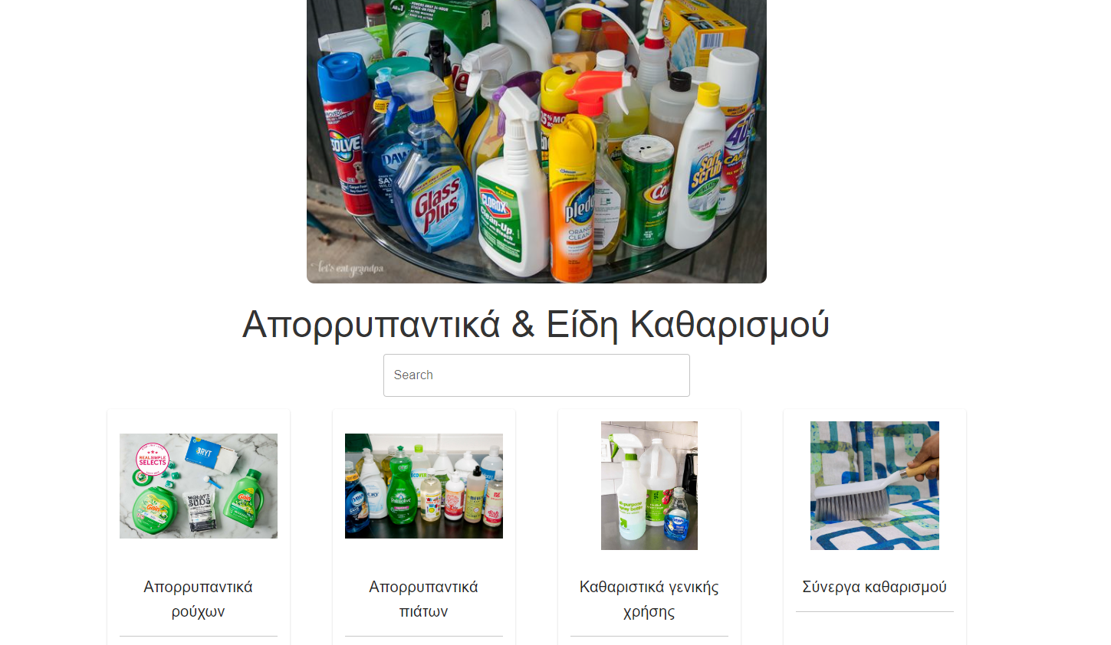

Directly under the category title, a **search bar** is available, allowing users to quickly search within the subcategories. This feature is particularly useful for users who already know what they are looking for and want to expedite the browsing process.

The page is organized into **subcategory cards**, each representing a more specific product type within the chosen parent category. Each card includes:

* A relevant image for the subcategory (e.g., images of laundry detergents, dishwashing liquids, general-purpose cleaners, and cleaning tools).
* A descriptive title below the image, written in Greek (e.g., "Απορρυπαντικά ρούχων" for **Laundry Detergents**, "Καθαριστικά γενικής χρήσης" for **General Cleaning Products**).

Clicking on any subcategory card will take the user to a more detailed product listing page for that specific subcategory.

## Product Listing Page

The **Product Detail Page** is designed to provide users with in-depth information about products within a specific subcategory. Once a user selects a subcategory from the Subcategory Page (e.g., **Laundry Detergents**), they are directed to this page, which lists all the available products under that subcategory, offering details such as the name of the product and its brand,an image of the product, and a button to add the item to the cart. The page aims to simplify the user’s shopping experience by presenting products in an organized, easy-to-browse manner.

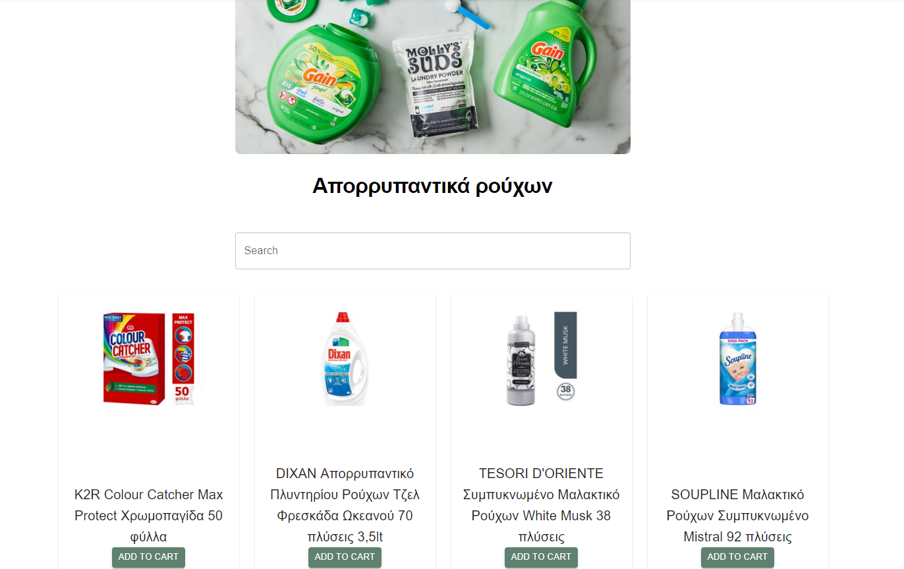

The primary content of the page is a grid of **product cards**, each representing an individual product within the chosen subcategory. Each product is represented by a high-quality image, making it easy for users to visually recognize the items they are interested in. Below each image, the product name and a brief description are displayed, including important details. Each product card features a clearly labeled "Add to Cart" button, allowing users to quickly add items to their shopping cart without needing to leave the page. The button is styled in a consistent color (e.g., green) to stand out and make the action intuitive. Users can scroll through the list of products, easily adding items to their cart as needed. The layout ensures that all relevant information is displayed clearly, reducing the cognitive load and helping users make quick decisions. The **search functionality** and **product cards** work in tandem to provide a seamless shopping experience, ensuring that users can either browse visually or use the search function to locate products efficiently.

## Cart

After the user adds a product in their cart a clear indicator below the cart icon is updated in order to inform the user of the number of items that are present in their cart. The cart is part of the navbar and is accessible to the user in every page allowing him to modify it’s content regardless of the page their currently visiting.

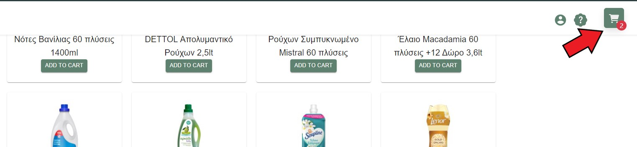

Clicking the cart icon opens an off canvas component from the left of the screen displaying all the selected products, with an red “X” button next to them allowing the user to remove them from the cart. At the bottom of the product list there is a green calculate button that when pressed moves the user to the **Checkout** page, the final page before the recommendation process starts, transferring his grocery list along the process.

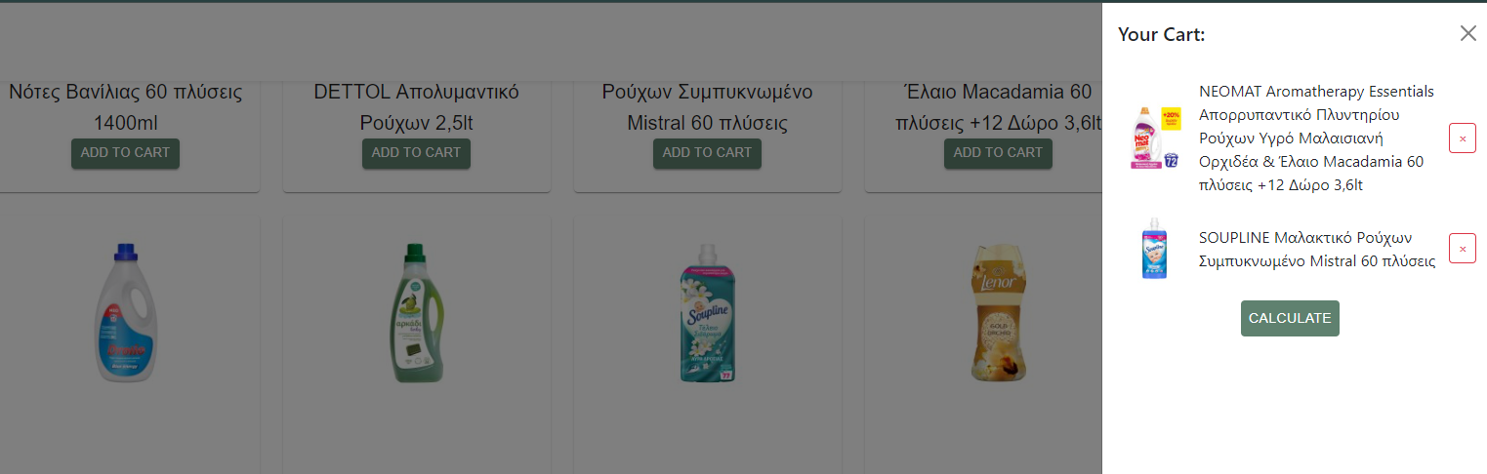

## Checkout Page

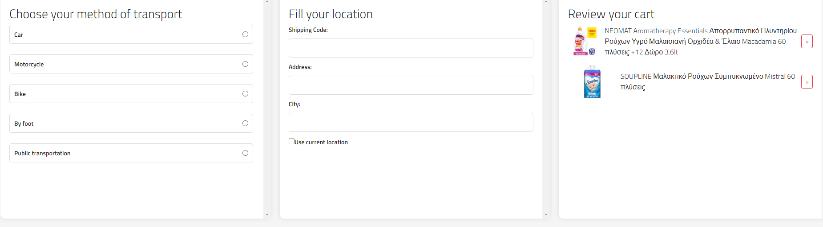The **Checkout Page** is the final step before users receive their personalized supermarket recommendations. It is designed to collect critical information required for generating accurate suggestions, such as the user’s mode of transportation, location, and a review of their shopping cart. The page is divided into three main sections, each serving a specific purpose to streamline the checkout process and ensure that the recommendation generated is tailored to the user’s preferences and context.

### Transportation Method Selection

On the left side of the page, users are prompted to **choose their method of transport**. This information plays a crucial role in the recommendation system, as the app considers transportation type when suggesting nearby supermarkets. The available options include:

* **Car**
* **Motorcycle**
* **Bike**
* **By Foot**
* **Public Transportation**

Each option is presented as a **radio button**, allowing users to easily select one. This selection is factored into the recommendation algorithm, as different transportation modes can influence the practicality of visiting certain supermarkets (e.g., supermarkets further away might be more suitable for users with cars).

### Location Information

The middle section of the page collects the user’s **location information**, which is essential for determining proximity to various supermarkets. This section includes fields for:

* **Shipping Code**: Users can enter their postal code, which helps to refine the geographic scope of recommendations.
* **Address**: The user’s street address, which provides more precise location data for the recommendation system.
* **City**: Users can enter their city to ensure that recommendations are localized.
* **Use Current Location**: A checkbox option allows users to enable geolocation features if they prefer to use their device’s GPS to automatically fill in their current location. This is a convenient option for users who may not want to manually input their address.

The location details provided here are combined with the transportation method to offer supermarket recommendations that are not only nearby but also accessible based on how the user intends to travel.

After the user clicks submit the section changes revealing a map with the location selected as well as a display of the current weather conditions on the selected location, shown as a text above the map.

### Cart Review

On the right side of the page, users can **review their shopping cart** before proceeding. This section lists all the items that the user has added to their cart, including:

* **Product Name**: The name of the product, shown in bold, along with a description if available.
* **Quantity**: The number of units or quantity of each product that has been added to the cart.
* **Remove Option**: Each product has a small **red "x" button** next to it, allowing users to remove items directly from the cart if they changetheir mind.

This feature provides flexibility, ensuring that the user can adjust their cart before generating a recommendation. The cart review section ensures that the user has an accurate view of all the products they plan to purchase, allowing them to make final adjustments before proceeding.

The **Checkout Page** is designed with simplicity and efficiency in mind. By breaking down the information into clearly defined sections—**transportation, location, and cart review**—users can easily provide the necessary details without feeling overwhelmed. The layout is intuitive, with each section logically placed to guide the user through the final steps of their shopping journey. As users make changes to their cart or location details, the application can process this information in real time to ensure that the final recommendation is as accurate as possible. The ability to automatically fill in location details using geolocation saves time and effort, making the checkout process smoother, especially for users who are in a hurry or unfamiliar with their postal code.

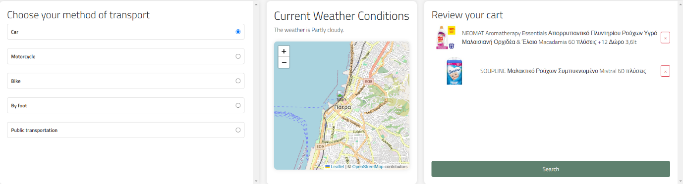After the user has provided all the necessary information a green Calculate button appears below their grocery list

### **Recommendation Page**

Clicking the button hides the three mention sectors and shows the user the final recommendation page which consists of:

* A sliding infinite **carousel** documenting the recommended supermarket, the cheapest supermarket and the nearest supermarket based on the information filled before. Below each supermarket a cost of the cart for each of the three options is displayed allowing the user to make a informative decision on which supermarket to visit on their own. This increases the likelihood of the user finding the final screen appealing and keeping him interested in using the app because even if the recommended supermarket is not of their liking, they can still find useful information about their shopping trip for other potentially suitable supermarkets.
* A **map** with the locations of the previous mentioned supermarkets shown as different color pins, the user location shown as an avatar as well as two button anchored at the top right of the map. The top one indicated with the filter icon, allows the user to remove or add pins of the before mentioned supermarkets to the map allowing for a increased visual clarity, while the second one indicated with a download button allows the user to download their grocery list in a pdf format, allowing them to use them as a reminder of what they need to shop when they visit the supermarket.

The user has also the possibility to click on the pins on the map which opens a pop up with a button “Get directions” that when pressed transfers the user to the google maps app and inputs directions between their input starting location and the supermarkets location, making it extremely easy and convenient for the user to navigate to supermarkets in locations he might not be familiar with.   
  
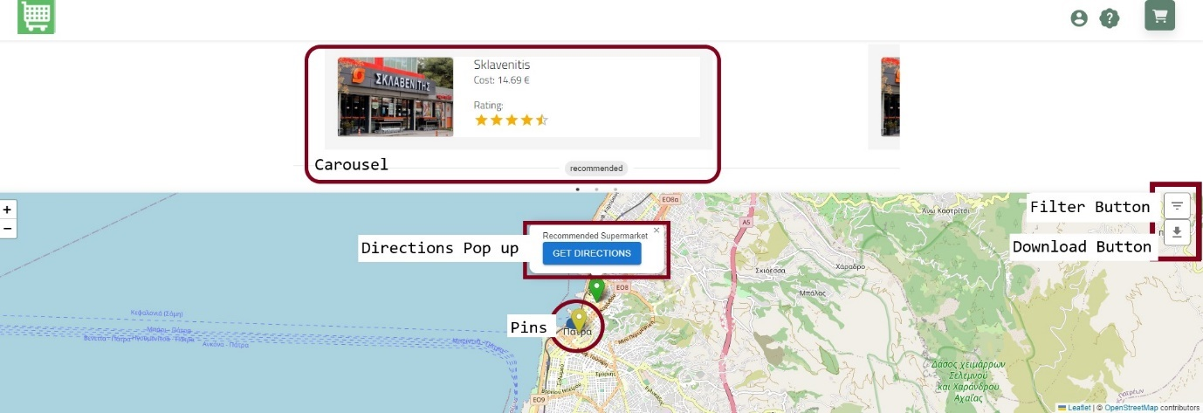

As seen in the image above the design of the recommendation page is minimal, containing all the required user information in a minimalistic way, showing parts of the information at the time. The fact that the cheapest and the nearest supermarket option is included, allows the app to be helpful and serve a purpose to the user even in the case that they do not agree with the recommendation.

## Sing Up/Sing In Page

The **Signin/Signup Page** allows users sign in, or create new accounts if they haven't already registered. It is divided into two main sections: **Sign In**, **Sign Up**. Each section offers a streamlined, user-friendly interface that ensures all the necessary data is being inputted with their corresponding format in the required fields.

### Sign In Page

The **Sign In Page** is the entry point for users who already have an account. The design is simple, yet visually engaging, featuring a split-screen layout with grocery-related images on the left and the sign-in form on the right. The left side of the screen display a split grayed out grocery-related image that connects and lights up after the user hovers over it, helping users feel connected to the application's purpose and providing them with a thing to distract their attention while they wait for their login to finish. For the username field placeholder is provided to guide users with an example (e.g., "e.g Jane Doe"), helping them fill out the form correctly. There is also a field for entering the user’s password, with placeholder text to indicate proper input. In case of wrong input data a warning message shows up in the button of the screen notifying the user.



### Sing Up Page

For users who do not have an account, the **Sign Up Page** offers a smooth registration process. The design remains consistent with the **Sign In Page**, with the same grocery image on the left. This continuity helps maintain the application's branding and keeps users familiar with the interface.

**Form Fields**:

* **Username**: The field includes a guide to help users choose a username.
* **Email Address**: An additional field is provided for users to input their email address, which will be used for account verification and communication.
* **Password**: A password field allows users to create a secure login for their account.

Each field turns to an indicative red outline color when incorrect format is present, allowing the user to easily identify the desired format of the input data for the creation of their account. If a duplicate is found the system notifies the user with a red message and the creation process stops.

## Account Page

The **Account Page** provides users with comprehensive tools to manage their profile information and saved shopping carts. This section of the application is designed to offer flexibility and control over shopping sessions, ensuring that users can continue their grocery planning seamlessly across multiple visits. The page allows users to view, modify, merge, and select previously saved shopping carts, offering a user-friendly interface for managing ongoing or previous shopping activities.

### Profile Information

At the top of the **Account Page**, users can see their basic account details, including:

* **Username** (e.g., "admin1").
* **Email Address** (e.g., "t1@t1.com").

Users are given two primary actions for account management:

* **Edit**: This option allows users to update their profile information, such as changing their username or email address.
* **Logout**: A button to safely log out of the account, securing their information when finished using the application.

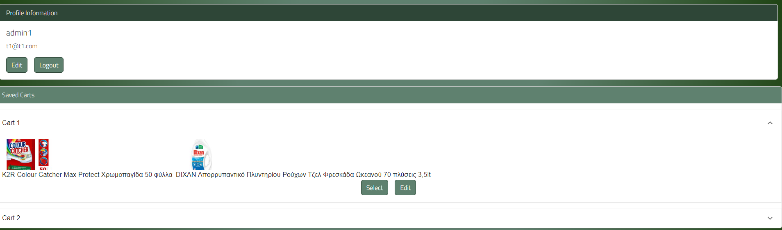

### Saved Carts Management

The **Saved Carts** section is a key feature of the **Account Page**, where users can access shopping carts they have previously saved. This section is structured to make it easy for users to review their past selections and manage ongoing shopping lists.

When the user creates an account, successfully logs in and adds a product to their cart, they are now presented with the option to save that cart on their account with a new button “**Save Cart**”.



**Cart Display and Actions**

Each saved cart is presented in a card format, displaying the items within the cart along with product images and descriptions

Users have two main options:

* **Select**: When a user clicks "Select," they are immediately navigated to the **Checkout Page**. The selected cart is pre-loaded into the checkout, allowing users to finalize their purchase with the items already saved in the cart.
* **Edit**: Clicking "Edit" lets users modify the contents of the saved cart. This action allows for item removal, giving users full control over what they wish to keep or discard.

**Merging Carts**

One of the more advanced features of the **Account Page** is the ability to merge two shopping carts. Users can do this via a **drag-and-drop** interface, where they can drag one cart onto another to combine their products.

After the merge, the products from both carts are consolidated into one, allowing users to create a single comprehensive list without duplicating or manually adding items across different carts.

The saved carts feature allows the users to plan their groceries ahead of time and quickly get the best recommendation for their shopping needs based on their current locations without needing to re-add every product they want. This allows for weekly grocery planning and overall improves the user experience making the whole transaction much quicker and easier. The **Account Page** empowers users to manage their shopping experience with a high level of flexibility. The ability to edit saved carts, remove unnecessary items, merge carts through drag-and-drop functionality, and quickly navigate to checkout with pre-selected carts streamlines the grocery planning process. The clean, intuitive design ensures that users can efficiently handle all aspects of their shopping lists, making it a valuable tool for users who regularly engage with the platform for their shopping needs.

## Help Chat Page

The **Help Page** in the application is presented as a **pop-up chatbot-style window** designed to assist users with any questions or issues they may encounter. The interface is simple and intuitive, offering users predefined options to select from. These options are tailored to answer common inquiries about the app’s functionalities, ensuring a seamless experience when navigating the platform. The **Help Page** makes it easy for users to find the information they need without having to leave their current workflow, adding to the application's user-friendly design.

### Key Features of the Help Page

**Chatbot Interface**

Upon accessing the help section, users are greeted with a message: "Welcome to BestMarket! How can I assist you today? (Please choose one of the options below)." This chatbot-like interface offers predefined questions that users can select to receive instant answers, helping them get the information they need quickly.

**Predefined Questions**

The interface provides three main questions for users to choose from:

* **What does BestMarket consider when making a recommendation?**
* **Can you show me all the supermarkets in my area and how frequently are they suggested?**
* **I need additional support**

Each of these options addresses a different aspect of the user’s potential needs, with clear and concise responses provided instantly.

**Question 1: "What does BestMarket consider when making a recommendation?"**

Upon selecting this question, the user receives an explanation of the factors considered in the recommendation process. The answer includes a breakdown of the **algorithm** used by BestMarket, which takes into account various factors:

* **Cost of groceries**.
* **Time of day**.
* **Weather conditions**.
* **Distance from the user to the supermarket**.
* **Rating of each supermarket**.
* **Means of transport**.

This response reassures users that the recommendations are based on a combination of personalized factors, ensuring that the system provides the best possible suggestion for their shopping needs.



**Question 2: "Can you show me all the supermarkets in my area and how frequently are they suggested?"**

For this query, the system provides a more interactive response by generating a **heatmap**. This map displays:

* **The user's current location**, using an avatar to indicate where they are.
* **Markers for nearby supermarkets**, each color-coded based on how frequently they are suggested by the app’s recommendation system using a heatmap gradient coloring from red (most frequent) to green (least frequent).



This heatmap allows users to visually assess the supermarkets in their area, helping them make more informed decisions about where to shop. The interactive map is powered by **Leaflet.js** and gives users an engaging and informative experience.

**Question 3: "I need additional support"**

For users who require further assistance, this option directs them to additional support resources. This could include connecting with a live representative, accessing detailed FAQs, or providing more specific help based on their current issue. This ensures that all users, regardless of their question complexity, can find the support they need.

The Help Page enhances the overall user experience by providing an interactive, chatbot-style interface that offers immediate answers to common questions. Whether explaining the recommendation process or showing users a heatmap of nearby supermarkets based on suggestion frequency, the help section ensures that users are fully supported throughout their journey. The heatmap feature in particular provides a unique and helpful way for users to visualize supermarket suggestions, further improving the decision-making process while using the app.

# 9. Experimental Results

Having thoroughly explored the generation and preprocessing of data, the training methodologies of the models, and their performance during training and validation in Chapter 7.4, as well as the comprehensive functioning of the complete system, our focus now shifts to the real-world efficacy of the models. This chapter is dedicated to evaluating the system's performance in live scenarios, specifically analyzing its responsiveness and accuracy across four distinct types of indicative conversations. The ensuing subsections will test the real-time outcomes of each model when confronted with these varied conversational contexts. Our objective is to assess the system's operational competence and to draw insights into its practical applicability, and reliability in dynamic, real-life settings that mimic actual user interactions.

The testing setup involves the use of two distinct speech input devices operating consecutively. The one device is designated to record the dialogue from the potential victim's perspective, while the second captures the words of the attacker or helper, simulating a real life scenario. The test workflow, which is diagrammatically represented in the subsequent figure 48, replicates the system's functionality similarly to Chapter 8. The key distinction in this setup from the one described in Chapter 8 is the use of two audio inputs where both capture audio data in a single computer but in different channels instead of one capturing the microphone data and the other one capturing the loopback data:

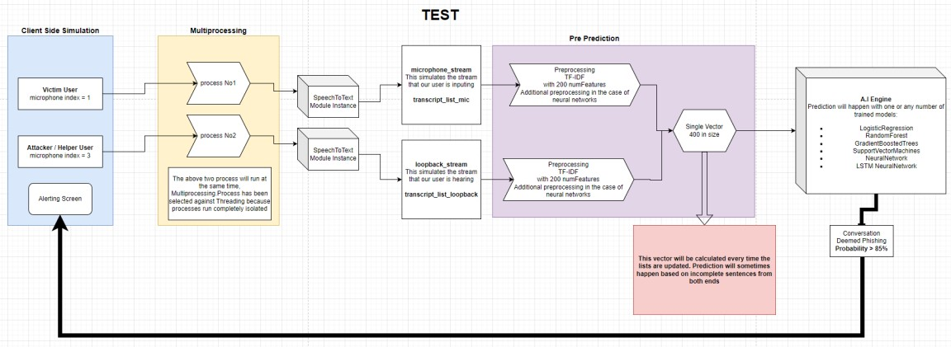

## Fig 55: Testing Workflow

The evaluation of our system's performance is structured around four conversation types as previously mentioned. These conversations are selected to gauge the adaptability and generalization capabilities of the algorithms in use. First, we analyze the system's response to a 'Vishing' conversation, a scenario that mirrors the context and structure the models have been trained on. Second, we assess the system's reaction to an unfamiliar 'Vishing' conversation—one with content and format not previously encountered during training. Moving forward, the third conversation type pertains to 'Non-Vishing' interactions that align closely with the models' training, allowing us to evaluate the system's accuracy in recognizing legitimate communications. The fourth and final conversation type presents a 'Non-Vishing' scenario that is new to the models, testing their ability to comprehend and correctly classify unseen and new formats. Through the examination of these four distinct conversational contexts, we aim to derive an understanding of the models' performance.

In this research, the Support Vector Machines (SVM) algorithm was determined to be unsuitable, because it does not provide probability estimates alongside its output predictions. As highlighted in Chapter 8, the ability to quantify prediction confidence in the form of probabilities is essential for the system's operation. Consequently, the results for the SVM algorithm will not be included in the forthcoming sections.

## 9.1 Model Performance on Familiar 'Vishing' Conversation

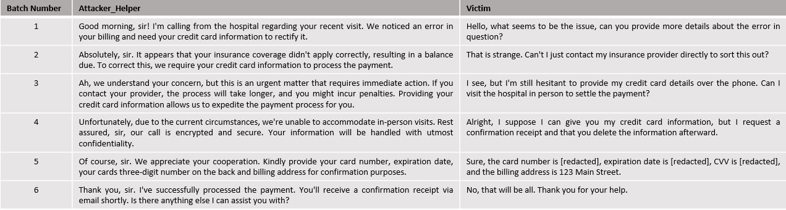

**Fig 56: ‘Vishing' Conversation with Known Formatting**

The context of the conversation depicted in figure 55 falls under the category of a "medical scam". In this scenario, the attacker attempts to deceive the victim by referencing a recent hospital visit, a tactic designed to instill a false sense of security in the victim. While all models in this study have been trained on various medical scam themes, this particular conversation has not been directly included in their training datasets. Our objective is to evaluate whether the models can identify that this conversation falls into the category of ‘Vishing’ sufficiently quick. The critical test in this case is to see if the algorithms can make the classification prior to the fifth batch of the conversation because in that batch the victim succumbs to the attack and provides the requested information to the attackers.

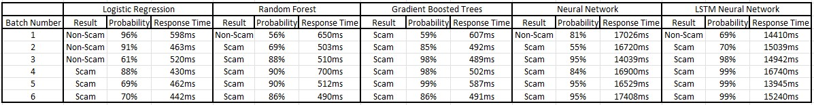

**Fig 57: Model Results on Familiar ‘Vishing’ Conversation**

* For the **Logistic Regression** model, the initial response is a categorization of 'NonScam' with a high probability. It's not until the fourth batch of the conversation that the model starts to indicate the possibility of a scam, and it is only in the fifth batch that it confidently categorizes the conversation as a scam with a high probability of 88%. Thus, the Logistic Regression model does succeed in identifying the conversation as a scam before the critical fifth batch.

* The performance of the **Random Forest** model contrasts with that of the Logistic Regression algorithm. Demonstrating a quicker response, the Random Forest model begins to suspect the 'Vishing' nature of the conversation earlier. By the fourth batch, it has already formed a relatively definitive conclusion, identifying the conversation as a scam with a probability of 90%. Given how quickly the model categorized the conversation correctly, the Random Forest algorithm can be regarded as successful in detecting the scam-like characteristics of the conversation.

* The response of the **Gradient Boosted Trees** model is immediately decisive. From the very first batch of the conversation, it identifies the scenario as a scam with a moderate probability of 59%. By the fourth batch, the probability of the conversation being a scam increases to 98%. This immediate level of confidence suggests that the model has recognized a pattern similar to what it encountered during training. However, this could also indicate potential overfitting, a hypothesis that requires further analysis in the subsequent discussion of model results, where more concrete data can increase our understanding of this matter.

* The **Neural Network** initially classifies the conversation as ‘Normal’ with a probability of 81% but then the model consistently classifies the conversation as a 'Scam' throughout the remainder of the duration of the conversation, increasing its probability from 55% on the second batch to 84% on the fourth batch. Therefore, the model successfully passes the challenge of this conversation which is to identify it correctly prior to the fifth batch of conversation.

* The **LSTM Neural Network** also successfully identifies the potential ‘scam’ nature of the conversation from the second batch, being more confident than the normal Neural Network model. Similarly, to the Gradient Boosted Trees algorithm, this model exhibits very high probabilities indicating that it too has identified a pattern similar to those witnessed in training.

The results of this test highlight the **Random Forest** algorithm as the best performer among all evaluated models. Its effectiveness is marked by a balanced approach, where it maintains neutrality where 'Vishing' characteristics in the conversation are ambiguous. Furthermore, the algorithm demonstrates the ability to discern suspicious elements in the conversation before the critical fifth batch, where the user falls victim to the scam. This quick classification is crucial, as any model that fails to detect the scam before this stage is deemed unsuccessful in this test.

**9.2 Model Performance on Unknown ‘Vishing’ Conversation**

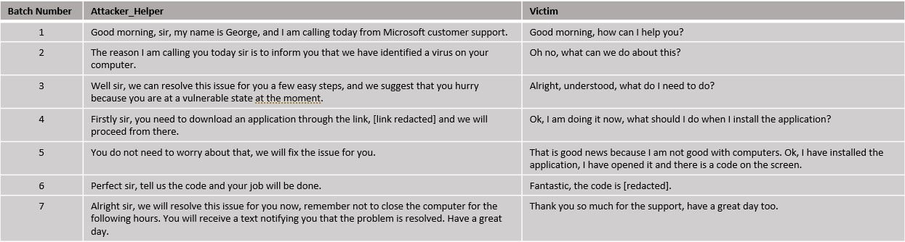

### Fig 58: Vishing conversation with Unknown formatting

The dialogue illustrated in figure 57 represents an example of a "technology scam." In this typical scenario, the scam revolves around deceiving the victim into believing there is a virus on their computer. The attackers then falsely claim they can remedy the issue, provided the victim follows a specific set of instructions they provide. The format and content of this conversation is unknown to the all the models. Our goal is to assess the models' ability to accurately categorize this conversation despite its novelty. Successfully doing so would be a good indicator of the models' capacity for generalization.

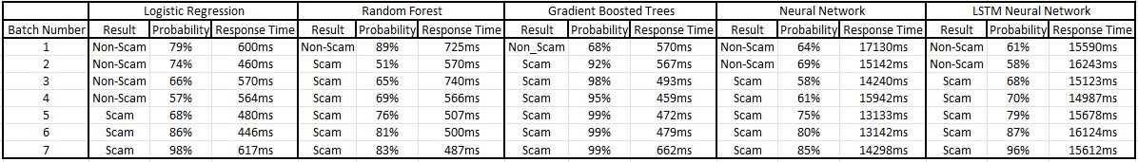

**Fig 59: Model Results on Unknown ‘Vishing’ Conversation**

* Much like in the previous conversation, the **Logistic Regression** model exhibits very good performance. It begins to exhibit signs of suspicion by the fourth batch. The fact that the model starts to identify the conversation as potentially suspicious in the fourth batch suggests that it maintains a balanced approach and it is not overly sensitive to the scam characteristics of the conversation.

* In contrast, the **Random Forest** model exhibits a more distinct level of suspicion. While it initially classifies the conversation as 'Non-Scam', it does so with relatively high confidence, with a probability of 89%. By the sixth batch, the model has formed its final stance, categorizing the conversation as a 'Scam' with a high probability of 81%.

* The **Gradient Boosted Trees** model exhibits very high certainty in correctly identifying the nature of the conversation. It consistently categorizes the conversation as ‘Scam' with its probability fluctuating around 95%.

* The **Neural Network model** initially identifies the conversation as 'Normal. It maintains this assessment until the third batch where it changes its opinion and suggests that the conversation is a possible ‘Scam’ with a probability of 58%. This is a very good performance since the model successfully predicts the conversation as it unfolds.

* Similar to the Neural Network model and the previous conversation example, the **LSTM Network** also successfully classifies the conversation, but with higher probability. This suggests that the LSTM model is more conservative in comparison to the Neural Network model since it is more sensitive to the ‘Scam’ characteristics of the conversation.

As a result, it appears that all models exhibit a desirable behavior with the **Neural Network** and **LSTM Network** showing the most promise. The **Logistic Regression** model also exhibits promising capabilities, as it successfully identifies the true nature of the conversation towards the middle. This indicates a gradual but accurate understanding of the conversation's context, highlighting the model's potential in effectively identifying such scenarios.

**9.3 Model Performance on Familiar ‘Normal’ Conversation**

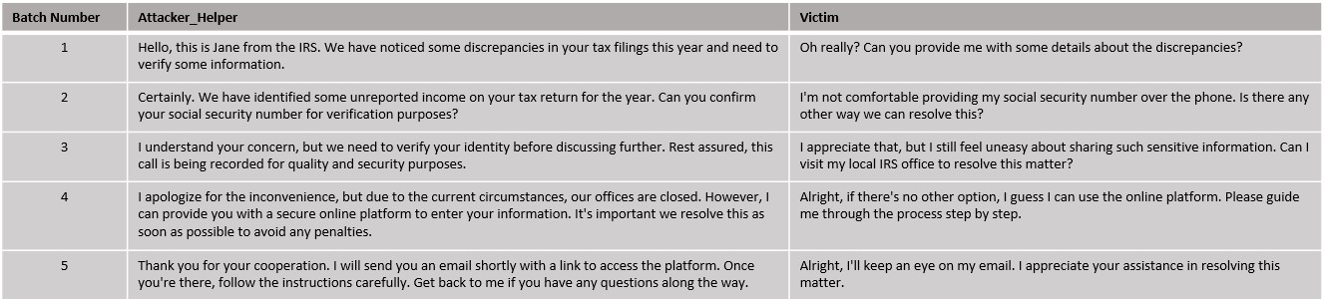

**Fig 60: Normal conversation with Known Formatting.**

The conversation illustrated in Figure 59 presents a scenario depicting an interaction between a person and an IRS officer. This conversation poses a unique challenge due to its ambiguous nature; it could easily be classified incorrectly as a scam. The format and content of this dialogue are familiar to the models since similar conversations have been included in the training data. The objective is to evaluate the models' ability to accurately identify and classify a normal, non-scam conversation.

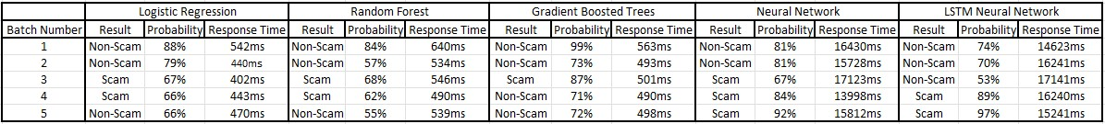

**Fig 61: Model Results on Familiar ‘normal’ Conversation**

* In analysis of the **Logistic Regression** model's performance, it's observed that the model initially classifies the conversation as 'normal' with a very high probability of around 84%. This high level of confidence is maintained up to the third batch of the conversation, after which the probability begins to fluctuate between 67% to 66%. This behavior suggests that while the algorithm initially recognizes a familiar pattern, it starts to exhibit skepticism by the fourth batch. On the fifth batch the model suggests that the conversation is indeed ‘Normal’ with a probability of 66%. Overall, despite these fluctuations, the model demonstrates a good performance in this test.

* The **Random Forest** model, like the Logistic Regression model, initially classifies the conversation as 'normal', starting with a lower probability of 84%. Its confidence plateaus at 57% for the second batch. By the third batch the model begins showing signs of suspicion which are maintained until the fourth batch. Similarly to the Logistic Regression model on the fifth batch it concludes that the conversation is indeed normal, and hence is deemed successful in this test.

* The **Gradient Boosted Trees** model immediately classifies the conversation as ‘normal’ with high probability, again indicating that the algorithm has identified a familiar pattern. This algorithm also exhibits significant suspicion on the third batch much like the other models but its quicker to overturn this suspicion by the fourth batch and solidify that choice in the fifth batch. Since the model successfully identifies the conversation and correctly displays suspicion where it is necessary, its performance is very good.

* Both the **Neural Network** and **LSTM Network** models exhibit similar behavior, classifying the conversation as ‘Vishing’ and maintaining that assessment throughout

the first two batches of conversation in the case of the Neural Network and three in the case of the LSTM Network. The Neural Network model suggests that the conversation is ‘Vishing’ by the third conversation and keeps this assessment throughout the remainder of the conversation while the LSTM Network does so by the fourth batch.

In conclusion, from this test, the **Logistic Regression**, **Random Forest**, and **Gradient Boosted Trees** models all exhibit good performance. Notably, the **Logistic Regression** and **Gradient Boosted Trees** models stand out, showing the most promise in their ability to accurately classify and adapt to the conversation presented.

**9.4 Model Performance on Unknown ‘Normal’ Conversation**

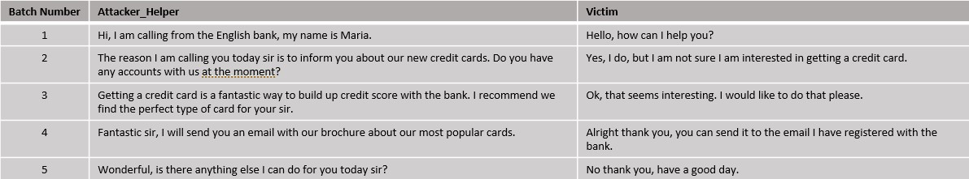

**Fig 62: Normal conversation with Unknown Formatting.**

The conversation depicted in the above Figure illustrates a phone conversation that revolves around the marketing of a bank’s new credit cards. Such a conversation has not been included in the training of the models and hence the challenge it poses is of critical importance. The aim of this test is to evaluate the model’s generalization abilities in a ‘normal’ unknown conversation.

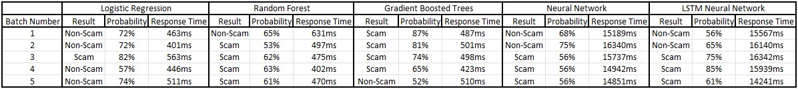

**Fig 63: Model Results on Unknown ‘normal’ Conversation**

* The performance of the **Logistic Regression** model in this scenario is impressive. Initially, the model classifies the conversation as 'normal' with a probability of 72% by the second batch. In the third batch, it alters its prediction to 'vishing', with a probability of 82%, suggesting it detected a feature it deemed suspicious. However, by the fourth batch, it reverts to its original classification of 'normal', again at 57% probability, and further reinforces this classification in the final batch with a heightened probability of 74%. This fluctuation and eventual stabilization in the model's predictions showcase its ability to dynamically assess and correctly categorize the conversation as 'normal', marking a successful performance in this test.

* The **Random Forest** model initially categorizes the conversation as 'normal', yet it does so with a relatively low confidence level, showing a probability of 65%. In the third batch, it changes its prediction to 'Vishing', assigning a probability of 53%. This probability level is approximately maintained for the remainder of the conversation. This pattern of behavior suggests that while the model's initial assessment is correct, it detects something potentially suspicious in the third batch and consequently maintains a state of alertness and suspicion for the duration of the conversation.

* The **Gradient Boosted Trees** model fails to pick up the ‘Normal’ characteristics of the conversation and maintains a suggestion of ‘Vishing’ up until the fourth batch of the conversation where it switches its decision to ‘Normal’ but with a low probability of 52%. This behavior suggests that the model eventually somewhat understands the meaning of the conversation as it progresses but in the context of this test it is considered failed.

* Both the **Neural Network** and **LSTM Network** models exhibit a similar pattern in their response to the conversation. They initially classify the conversation as ‘Normal’ right from the start and maintain this classification up until the second batch. Both models then switch their prediction to ‘Vishing’ with the Neural Network maintaining a probability of around 56% and the LSTM Networks probability ranging from 75% to 61% on the final batch.

As a result of this test, the **Logistic Regression** model emerges as the best performer among the algorithms evaluated, demonstrating a more accurate and consistent classification ability. This suggests that, of the five models tested, the Logistic Regression model possesses the strongest capability for generalization in ‘Normal’ scenarios, effectively adapting to and correctly identifying the conversational context.

## 9.5 Response Time Performance Evaluation

As emphasized in Chapter 8, the response time of the system is crucial for the task at hand. In terms of overall performance, the PySpark models (comprising Logistic Regression, Random Forest, and Gradient Boosted Trees) demonstrate a consistent response time within the full system functionality, averaging at about 500ms. On the other hand, the Neural Network model and the LSTM Network model show a response time of approximately 15 seconds. This discrepancy in response times between the PySpark models and the Neural Network-based models is in line with the expectations and analysis presented in Chapter 8.

## 9.6 Overall Results

In conclusion, the Logistic Regression and Random Forest models demonstrate the most effective performance among the tested algorithms, with Logistic Regression model being the better of the two. These models have successfully learned underlying patterns during training, enabling them to differentiate between 'Vishing' and 'Normal' conversations. Throughout the various conversation tests, they have shown an ability to make reasoned decisions and adapt their responses when necessary. This is observed in instances where a suspicious phrase is mentioned; both models show a shift in their probability predictions, as illustrated in the test example 9.4 for reference.

On the other hand, the Gradient Boosted Trees algorithm tends to perform well on data similar to its training set, often showing high confidence in its decisions. However, this behavior suggests a potential overfitting issue, as evidenced by its less effective performance on unfamiliar and ambiguous conversations.

The Neural Network and LSTM models also show great performance throughout but tend to label conversations as 'Vishing' more often than 'Normal', a behavior especially noticeable in the Neural Network model compared to the LSTM.

Overall, the Logistic Regression and Random Forest models demonstrate promising results, whereas the other models face challenges in accurately classifying conversations. This outcome aligns with expectations, given the relatively small size of the training dataset compared to what is typically required for such tasks. Nevertheless, the results are encouraging: the aforementioned models successfully identified 'Scam-like' characteristics in conversations that were new to them, indicating a good ability to generalize effectively despite the limited data and diversity of those data encountered during training.

# 10. Deductions, Limitations and Future Research

This dissertation aimed to explore the viability of a real-time voice phishing (vishing) detection system utilizing machine learning technologies. We delved into various components such as PySpark and the Speech-To-Text module, the creation and preprocessing of the dataset manufactured for this task, and the selection, functionality, training, and tuning of the models. As a result of the training process the Logistic Regression and Random Forest models stood out for their optimal performance in addressing our problem.

In the last chapters of this study, we demonstrated how these components and models integrate into a unified system, showcasing its real-time performance across four distinct conversational scenarios. Notably, the Logistic Regression and Random Forest models showed promising results, being able to adequately detect both ‘Vishing’ and ‘Normal’ conversations with the system's response times averaging around 500ms.

The research yielded encouraging outcomes, particularly with the strong real-time testing performance of the Logistic Regression and Random Forest models, showing that further exploration in this domain can result in the solution of the problem at hand which is identifying ‘Vishing’ conversations quickly.

However, the study faced challenges, notably the limited diversity in the training dataset created via the Chat GPT API, leading to a reduced generalization ability in the models. Additionally, the dataset's size was smaller than ideal for such a complex task, complicating the models' training and generalization. Despite implementing several techniques to mitigate overfitting and enhance generalization, these issues persisted in some models.

Future efforts should focus on developing a robust and diverse dataset. This dataset should include a wide range of everyday conversations and sophisticated scam dialogues, enabling the models to detect and counter advanced fraudulent tactics but understand at the same time when a conversation is completely normal.

This research paves the way for advancements in user protection against phone-based scams, a critical issue in today's technology-driven society. The development of an effective, sustainable system capable of real-time vishing detection could significantly enhance telephonic security.

Reflecting on this journey, the potential of machine learning in combating vishing is evident, yet the path consists of challenges as mentioned previously. The promising results from the Logistic Regression and Random Forest models underscore the feasibility of the task yet highlight the necessity for continued innovation and refinement. This dissertation adds valuable insights to the conversation about cybersecurity and highlights how important it is to keep people safe as we rely more on digital technology. Looking ahead, it's crucial to work on making our data more varied and our models more reliable. Doing so will help us fully unlock the possibilities of detecting vishing in real-time, leading to safer ways of communicating.

# Bibliography

1. “Inside the intricate world of voice phishing” [Online]. Available: [https://koreajoongangdaily.joins.com/2019/02/01/socialAffairs/Inside-the-intricate-worldof-voice-phishing/3059014.html](https://koreajoongangdaily.joins.com/2019/02/01/socialAffairs/Inside-the-intricate-world-of-voice-phishing/3059014.html)
2. “Voice Phishing” [Online]. Available: <https://en.wikipedia.org/wiki/Voice_phishing>
3. “What Is a Vishing Attack?” [Online]. Available: <https://www.fortinet.com/resources/cyberglossary/vishing-attack>
4. “What is Vishing?” [Online]. Available: <https://softwarelab.org/blog/what-is-vishing/>
5. “What is Dumpster Diving?” [Online]. Available: <https://www.techtarget.com/searchsecurity/definition/dumpster-diving>
6. Song, J., Kim, H., & Gkelias, A. (2014). iVisher: Real‐Time Detection of Caller ID Spoofing. *ETRI Journal*, *36*(5), 865-875.
7. Norris, G., & Brookes, A. (2021). Personality, emotion and individual differences in response to online fraud. *Personality and Individual Differences*, *169*, 109847.
8. Jones, K. S., Armstrong, M. E., Tornblad, M. K., & Siami Namin, A. (2021). How social engineers use persuasion principles during vishing attacks. *Information & Computer Security*, *29*(2), 314-331.
9. “What is a Vishing Attack | Examples & Preventions.” [Online]. Available: <https://www.imperva.com/learn/application-security/vishing-attack/>
10. Xing, J., Yu, M., Wang, S., Zhang, Y., & Ding, Y. (2020). Automated fraudulent phone call recognition through deep learning. *Wireless Communications and Mobile Computing*, *2020*, 1-9.
11. Lee, M., & Park, E. (2023). Real-time Korean voice phishing detection based on machine learning approaches. *Journal of Ambient Intelligence and Humanized Computing*, *14*(7), 8173-8184.
12. Tran, M. H., Hoai, T. H. L., & Choo, H. (2020). A third-party intelligent system for preventing call phishing and message scams. In *Future Data and Security Engineering. Big Data, Security and Privacy, Smart City and Industry 4.0 Applications: 7th International Conference, FDSE 2020, Quy Nhon, Vietnam, November 25–27, 2020, Proceedings 7* (pp. 486492). Springer Singapore.
13. Salloum, S., Dautov, R., Chen, X., Peng, P. X., & Huang, J. Z. (2016). Big data analytics on Apache Spark. *International Journal of Data Science and Analytics*, *1*, 145-164.
14. Assefi, M., Behravesh, E., Liu, G., & Tafti, A. P. (2017, December). Big data machine learning using apache spark MLlib. In *2017 ieee international conference on big data (big data)* (pp. 3492-3498). IEEE.
15. Armbrust, M., Xin, R. S., Lian, C., Huai, Y., Liu, D., Bradley, J. K., ... & Zaharia, M. (2015, May). Spark sql: Relational data processing in spark. In *Proceedings of the 2015 ACM SIGMOD international conference on management of data* (pp. 1383-1394).
16. “The Spark Cluster architecture for resource allocation and data transfer.” [Online]. Available: [https://www.researchgate.net/figure/The-Spark-cluster-architecture-forresource-allocation-and-data-transfer_fig3_337305063](https://www.researchgate.net/figure/The-Spark-cluster-architecture-for-resource-allocation-and-data-transfer_fig3_337305063)
17. “Apache Spark Components.” [Online]. Available:

<https://intellipaat.com/blog/tutorial/spark-tutorial/apache-spark-components/>

1. “Key features of Spark’s MLlib.” [Online]. Available: [https://www.researchgate.net/figure/Key-features-of-Sparks-MLlib-asparkmllib-is-built-ontop-of-RDDs-bsparkml-is-built_fig6_309138349](https://www.researchgate.net/figure/Key-features-of-Sparks-MLlib-asparkmllib-is-built-on-top-of-RDDs-bsparkml-is-built_fig6_309138349)
2. Meng, X., Bradley, J., Yavuz, B., Sparks, E., Venkataraman, S., Liu, D., ... & Talwalkar, A. (2016). Mllib: Machine learning in apache spark. *The journal of machine learning research*, *17*(1), 1235-1241.
3. “Optimization – RDD - based API.” [Online]. Available: <https://spark.apache.org/docs/latest/mllib-optimization.html>
4. “Broyden-Fletcher-Goldfarb-Shanno algorithm.” [Online]. Available:

[https://en.wikipedia.org/wiki/Broyden%E2%80%93Fletcher%E2%80%93Goldfarb%E2%80%9 3Shanno_algorithm](https://en.wikipedia.org/wiki/Broyden%E2%80%93Fletcher%E2%80%93Goldfarb%E2%80%93Shanno_algorithm)

1. “Spark Machine Learning Pipelines.” [Online]. Available: <https://spark.apache.org/docs/latest/ml-pipeline.html>
2. “Spark Machine Learning Pipeline for regression.” [Online]. Available: <https://gbhat.com/spark/spark_ml_regression_pipeline.html>
3. “Spark Streaming Guide.” [Online]. Available: <https://spark.apache.org/docs/latest/streaming-programming-guide.html>
4. “What is Speech to Text?” [Online]. Available: [https://aws.amazon.com/whatis/speech-to-text/](https://aws.amazon.com/what-is/speech-to-text/)
5. Trivedi, A., Pant, N., Shah, P., Sonik, S., & Agrawal, S. (2018). Speech to text and text to speech recognition systems-Areview. *IOSR J. Comput. Eng*, *20*(2), 36-43.
6. “Speech-to-Text: Automatic Speech Recognition.” [Online]. Available: <https://cloud.google.com/speech-to-text/?hl=en#all-features>
7. “Generative pre-trained transformer.” [Online]. Available: <https://en.wikipedia.org/wiki/Generative_pre-trained_transformer>
8. “Transformer” [Online]. Available: <https://en.wikipedia.org/wiki/Transformer_(machine_learning_model)>
9. “What is a Transformer?” [Online]. Available: [https://medium.com/inside-machinelearning/what-is-a-transformer-d07dd1fbec04](https://medium.com/inside-machine-learning/what-is-a-transformer-d07dd1fbec04)
10. “Prompt Engineering” [Online]. Available: <https://en.wikipedia.org/wiki/Prompt_engineering>
11. “Master the Perfect ChatGPT Prompt Formula” [Online]. Available:

[Campaign_GRE_Tell2_Instream (youtube.com)](https://www.youtube.com/watch?v=jC4v5AS4RIM)

1. “What is Tokenization?” [Online]. Available: [What is Tokenization? Types, Use Cases, Implementation | DataCamp](https://www.datacamp.com/blog/what-is-tokenization)
2. “Tokenization in Natural Language Processing” [Online]. Available: [Tokenization in Natural Language Processing | by Mohammad Derakhshan | Medium](https://medium.com/@m.derakhshan/tokenization-in-natural-language-processing-86e4e235a2aa)
3. Perkins, J. (2010). *Python text processing with NLTK 2.0 cookbook*. PACKT publishing.
4. “NLTK Documentation” [Online]. Available: <https://www.nltk.org/api/nltk.tokenize.word_tokenize.html>
5. “Introduction to Stemming” [Online]. Available: <https://www.geeksforgeeks.org/introduction-to-stemming/>
6. “All you need to know about text preprocessing for NLP and Machine Learning” [Online]. Available: [https://www.kdnuggets.com/2019/04/text-preprocessing-nlp-machinelearning.html](https://www.kdnuggets.com/2019/04/text-preprocessing-nlp-machine-learning.html)
7. “Stemming” [Online]. Available: <https://en.wikipedia.org/wiki/Stemming>
8. “Flatten PySpark function” [Online]. Available: [https://spark.apache.org/docs/latest/api/python/reference/pyspark.sql/api/pyspark.sql.fun ctions.flatten.html](https://spark.apache.org/docs/latest/api/python/reference/pyspark.sql/api/pyspark.sql.functions.flatten.html)
9. “Tf-Idf” [Online]. Available: <https://en.wikipedia.org/wiki/Tf%E2%80%93idf>[42] “Feature Hashing” [Online]. Available: <https://en.wikipedia.org/wiki/Feature_hashing>
10. “Machine Learning” [Online]. Available: <https://en.wikipedia.org/wiki/Machine_learning>
11. Hastie, T., Tibshirani, R., Friedman, J., Hastie, T., Tibshirani, R., & Friedman, J. (2009). Overview of supervised learning. *The elements of statistical learning: Data mining, inference, and prediction*, 9-41.
12. “Supervised Learning” [Online]. Available: <https://en.wikipedia.org/wiki/Supervised_learning>
13. “Unsupervised Learning” [Online]. Available: <https://en.wikipedia.org/wiki/Unsupervised_learning>
14. James, G., Witten, D., Hastie, T., Tibshirani, R., & Taylor, J. (2023). Unsupervised learning. In *An Introduction to Statistical Learning: with Applications in Python* (pp. 503-556). Cham: Springer International Publishing.
15. Mnih, V., Kavukcuoglu, K., Silver, D., Rusu, A. A., Veness, J., Bellemare, M. G., ... & Hassabis, D. (2015). Human-level control through deep reinforcement learning. *nature*, *518*(7540), 529-533.
16. Ying, X. (2019, February). An overview of overfitting and its solutions. In *Journal of physics: Conference series* (Vol. 1168, p. 022022). IOP Publishing.
17. “Underfitting and Overfitting in machine learning and how to deal with it.” [Online]. Available: [https://towardsdatascience.com/underfitting-and-overfitting-in-machinelearning-and-how-to-deal-with-it-6fe4a8a49dbf](https://towardsdatascience.com/underfitting-and-overfitting-in-machine-learning-and-how-to-deal-with-it-6fe4a8a49dbf)
18. Shorten, C., Khoshgoftaar, T. M., & Furht, B. (2021). Text data augmentation for deep learning. *Journal of big Data*, *8*, 1-34.
19. “Data augmentation” [Online]. Available: <https://en.wikipedia.org/wiki/Data_augmentation>
20. “Regularization in Machine Learning” [Online]. Available: <https://www.geeksforgeeks.org/regularization-in-machine-learning/>
21. “Cross-validation (statistics)” [Online]. Available: [https://en.wikipedia.org/wiki/Crossvalidation_(statistics)](https://en.wikipedia.org/wiki/Cross-validation_(statistics))
22. “Binary Classification” [Online]. Available: <https://en.wikipedia.org/wiki/Binary_classification>
23. “Logistic Regression in Machine Learning” [Online]. Available: <https://www.geeksforgeeks.org/understanding-logistic-regression/>
24. “Logistic Regression” [Online]. Available: <https://en.wikipedia.org/wiki/Logistic_regression>
25. “Support Vector Machine (SVM) Algorithm” [Online]. Available: <https://www.geeksforgeeks.org/support-vector-machine-algorithm/>
26. “Support Vector Machine” [Online]. Available: <https://en.wikipedia.org/wiki/Support_vector_machine>
27. “Support Vector Machine-Based EMG Signal Classification Techniques: A Review” [Online]. Available: <https://www.mdpi.com/2076-3417/9/20/4402>
28. “Support Vector Machines (SVM)” [Online]. Available: <https://learnopencv.com/support-vector-machines-svm/>
29. De Ville, B. (2013). Decision trees. *Wiley Interdisciplinary Reviews: Computational Statistics*, *5*(6), 448-455.
30. “Decision Tree” [Online]. Available: <https://en.wikipedia.org/wiki/Decision_tree>
31. “What is a Decision Tree?” [Online]. Available: <https://www.geeksforgeeks.org/decision-tree/>[65] “Random Forest” [Online]. Available: <https://en.wikipedia.org/wiki/Random_forest>
32. “Bootstrap aggregating” [Online]. Available:

<https://en.wikipedia.org/wiki/Bootstrap_aggregating>

1. “Gradient boosting” [Online]. Available: <https://en.wikipedia.org/wiki/Gradient_boosting#Gradient_tree_boosting>
2. “Gradient Boosting in Machine Learning” [Online]. Available: <https://www.geeksforgeeks.org/ml-gradient-boosting/>
3. “The Evolution and Core Concepts of Deep Learning and Neural Networks” [Online]. Available: [https://www.analyticsvidhya.com/blog/2016/08/evolution-core-concepts-deeplearning-neural-networks/](https://www.analyticsvidhya.com/blog/2016/08/evolution-core-concepts-deep-learning-neural-networks/)
4. “What is a neural network?” [Online]. Available: <https://www.geeksforgeeks.org/neural-networks-a-beginners-guide/>
5. “Activation functions in Neural Networks” [Online]. Available: <https://www.geeksforgeeks.org/activation-functions-neural-networks/>
6. “Softmax function” [Online]. Available: [https://www.geeksforgeeks.org/activationfunctions-neural-networks/](https://www.geeksforgeeks.org/activation-functions-neural-networks/)
7. “A Gentle Introduction to Dropout for Regularizing Deep Neural Networks” [Online]. Available: [https://machinelearningmastery.com/dropout-for-regularizing-deep-neuralnetworks/](https://machinelearningmastery.com/dropout-for-regularizing-deep-neural-networks/)
8. “Gradient Descent Algorithm in Machine Learning” [Online]. Available: <https://www.geeksforgeeks.org/gradient-descent-algorithm-and-its-variants/>
9. “Backpropagation in Data Mining” [Online]. Available: <https://www.geeksforgeeks.org/backpropagation-in-data-mining/>
10. “Long short-term memory” [Online]. Available: <https://en.wikipedia.org/wiki/Long_short-term_memory>
11. “Understanding of LSTM Networks” [Online]. Available: <https://www.geeksforgeeks.org/understanding-of-lstm-networks/>
12. “Understanding LSTMs” [Online]. Available: [https://kushalj001.github.io/black-boxml/lstm/pytorch/gates/vanishing%20gradient/2019/12/28/Understanding-LSTMs.html](https://kushalj001.github.io/black-box-ml/lstm/pytorch/gates/vanishing%20gradient/2019/12/28/Understanding-LSTMs.html)
13. “Introduction to the Keras Tuner” [Online]. Available: <https://www.tensorflow.org/tutorials/keras/keras_tuner>
14. “Hyperband Tuner” [Online]. Available: <https://keras.io/api/keras_tuner/tuners/hyperband/>
15. Kingma, D. P., & Ba, J. (2014). Adam: A method for stochastic optimization. *arXiv preprint arXiv:1412.6980*.
16. “Intuition of Adam Optimizer” [Online]. Available: <https://www.geeksforgeeks.org/intuition-of-adam-optimizer/>
17. “Stochastic Gradient Descent (SGD)” [Online]. Available: <https://www.geeksforgeeks.org/ml-stochastic-gradient-descent-sgd/>
18. “Tuning Your Keras SGD Neural Network Optimizer” [Online]. Available: [https://kyle-rkieser.medium.com/tuning-your-keras-sgd-neural-network-optimizer-768536c7ef0](https://kyle-r-kieser.medium.com/tuning-your-keras-sgd-neural-network-optimizer-768536c7ef0)
19. “Gradient Descent With RMSProp from Scratch” [Online]. Available: <https://www.geeksforgeeks.org/gradient-descent-with-rmsprop-from-scratch/>
20. “Gradient Descent Optimization With Nadam From Scratch” [Online]. Available: [https://machinelearningmastery.com/gradient-descent-optimization-with-nadam-fromscratch/](https://machinelearningmastery.com/gradient-descent-optimization-with-nadam-from-scratch/)